STANDARD OPERATING PROCEDURE

Add Equipment
How to register forklifts, fleet vehicles, vans, tools, and other individually tracked equipment in ScanOps.
PURPOSE
Create one accurate equipment record and one unique QR for each physical unit so identity, site, status, and scan history remain traceable.

Applies to
- Forklifts and material-handling units
- Fleet trucks, vans, trailers, and mobile units
- Tools and other individually tracked equipment
- Employees authorized to create or maintain equipment records

Owner and approval
The Equipment Administrator or designated supervisor owns record creation. The physical unit, serial/VIN, location, and QR must be verified before release for operational use.
IMPORTANT SEPARATION
Equipment is separate from stocked Inventory. Do not create forklifts, fleet, or tools as catalog SKUs or on-hand inventory.

BEFORE ENTRY

1. Gather and verify equipment data

Required information
- Unit name: a unique, recognizable operating name.
- Type: the closest approved equipment category.

Recommended information
- Serial number or VIN, copied directly from the manufacturer plate or registration.
- Assigned location or site.
- Initial status—normally Active only when the unit is approved for use.
- Notes such as make/model, department, custodian, condition, or acquisition reference.

Naming convention
Use a consistent format such as Site – Type – Number (example: Main DC – Dock Forklift – 02). Do not use a person’s name as the permanent unit identity.

Duplicate check
- Search the Equipment register by unit name and serial/VIN.
- Inspect similar records and inactive units.
- If a matching physical unit already exists, update the existing record instead of creating a duplicate.
STOP AND ESCALATE
Do not proceed when the serial/VIN is unreadable, the unit already exists, ownership is unclear, or the equipment is quarantined pending safety review.

SYSTEM PROCEDURE

2. Add the equipment record
- Select Equipment from the left navigation.
- In Add Equipment → New unit, enter the unique Unit name.
- Select the correct Type, such as Forklift, fleet vehicle, van, or tool.
- Enter Serial/VIN when available.
- Enter the Assigned location/site.
- Select the correct status. Use Active only for units authorized for operation.
- Keep Auto-generate unique QR selected and leave Generate a unique QR checked (recommended).
- Enter useful Notes without storing sensitive personal information.
- Review all fields against the physical unit and source documentation.
- Select Add equipment once. Wait for confirmation before clicking again.
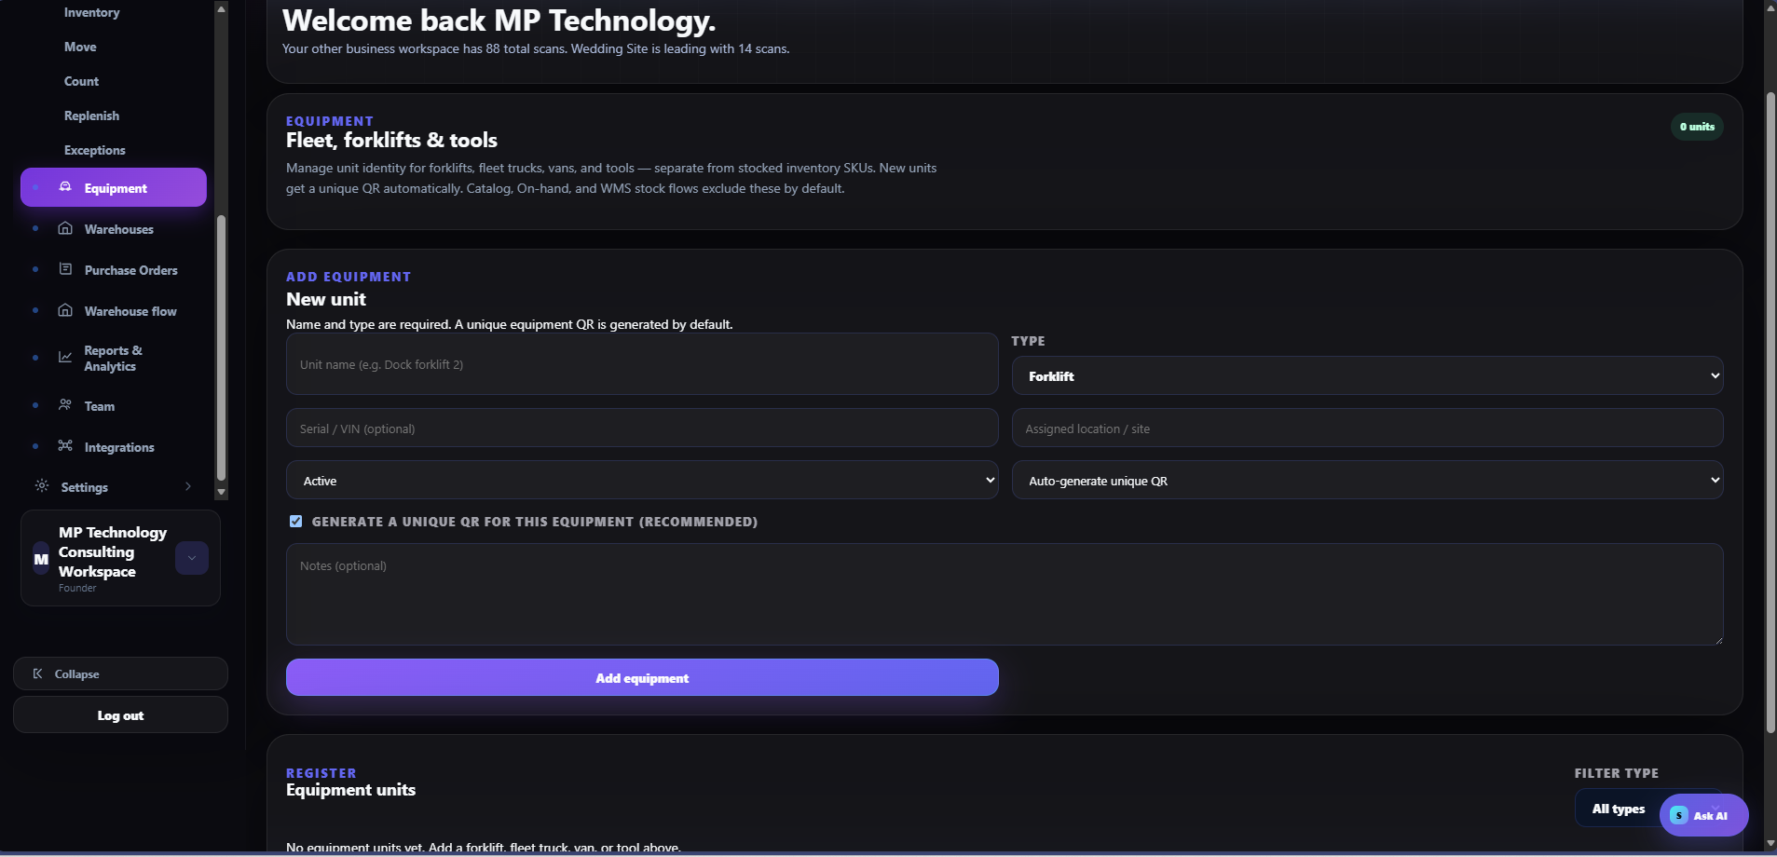
Equipment → Add Equipment: create a controlled unit record and its unique QR.

QUALITY CONTROL

3. Verify the record and QR
- Confirm the new unit appears in the Equipment units register.
- Open the record and verify name, type, serial/VIN, location/site, status, and notes.
- Confirm a unique equipment QR was generated.
- Print or export the approved QR label.
- Apply the label to a clean, visible surface that does not interfere with controls, warnings, plates, heat, or moving components.
- Scan the QR with the production device. Confirm it opens the correct equipment record.
- Record the installation date or verifier when local policy requires it.

QR placement rules
- Use a consistent location for the same equipment type.
- Avoid curved, oily, hot, abrasive, or frequently replaced surfaces.
- Do not cover safety labels, VIN/serial plates, inspection decals, or regulatory markings.
- Use protective laminate or durable media appropriate to the environment.
ACCEPTANCE STANDARD
The record is complete only when the physical unit, serial/VIN, system record, assigned site, status, and scanned QR all agree.

AFTER CREATION

4. Corrections, status changes & controls

If information is wrong
- Open the existing equipment record.
- Correct the inaccurate field and document the reason when required.
- Rescan the QR and verify the revised record.
- Do not create a replacement record merely to fix a typo.

If the QR is damaged or lost
- Open the existing unit record.
- Reprint or regenerate the label using the same equipment identity, according to system controls.
- Remove or destroy the unusable label.
- Apply and scan-test the replacement.

Status management
- Active: approved and available for use.
- Inactive: temporarily or permanently unavailable; retain history.
- Use the organization’s approved status for maintenance, quarantine, lost, sold, or retired equipment when available.
- Never delete or duplicate a record to hide history.

Completion checklist
☐ Duplicate search completed
☐ Unit name and type verified
☐ Serial/VIN verified or documented as unavailable
☐ Location/site assigned
☐ Status correct
☐ Unique QR generated
☐ Label applied safely
☐ QR scan opens the correct unit
☐ Supervisor approval recorded when required
AUDIT RULE
One physical unit = one equipment record = one unique equipment QR. Equipment does not change catalog or on-hand stock balances.

