STANDARD OPERATING PROCEDURE

Add Teammates & Floor Devices
A least-privilege procedure for provisioning individual accounts, email invitations, warehouse responsibilities, and shared floor-device access.
PURPOSE
Give each person or approved shared device only the access needed to perform assigned work, while preserving accountability and protecting Team, Billing, catalog, and warehouse controls.

Applies to
- Owners and authorized team administrators
- Operations leads and warehouse supervisors
- Workers using individual logins
- Approved shared phones or floor devices using the Floor PIN

Core rules
- Use one named account per teammate whenever possible.
- Choose the lowest role and fewest responsibilities that support the job.
- Use Owner only for Team/Billing authority.
- Never share an Owner or Member password on a floor device.
- Review active members, pending invites, and device access routinely.
SECURITY STOP
Do not provision access without manager approval, a confirmed business need, an approved role, and a defined end date for temporary workers or devices.

PLAN ACCESS

1. Select the correct access model

Role sets the ceiling
Role | Use for | Key boundary
Worker | Floor receive, putaway, pick, pack, ship, and cycle-count duties. | Responsibilities expand permitted warehouse views within the plan.
Member | Operations/catalog lead needing catalog edit, import/export, or QR creation. | Cannot manage Team or Billing.
Owner | Workspace authority requiring Team or Billing management. | Full control; assign only when required.

Responsibilities
- Receive: inbound receiving views and API.
- Putaway: LPN putaway and location moves.
- Pick: pick and warehouse-flow views/API.
- Pack: packing and shipping pack steps.
- Ship: ship views and carrier dispatch.
- Cycle count: floor counting access.
- Admin: floor lead with full inventory navigation and catalog edit within plan; this is not Owner.
DECISION RULE
Worker + selected responsibilities for floor staff; Member for catalog/operations leads; Owner only for Team/Billing.
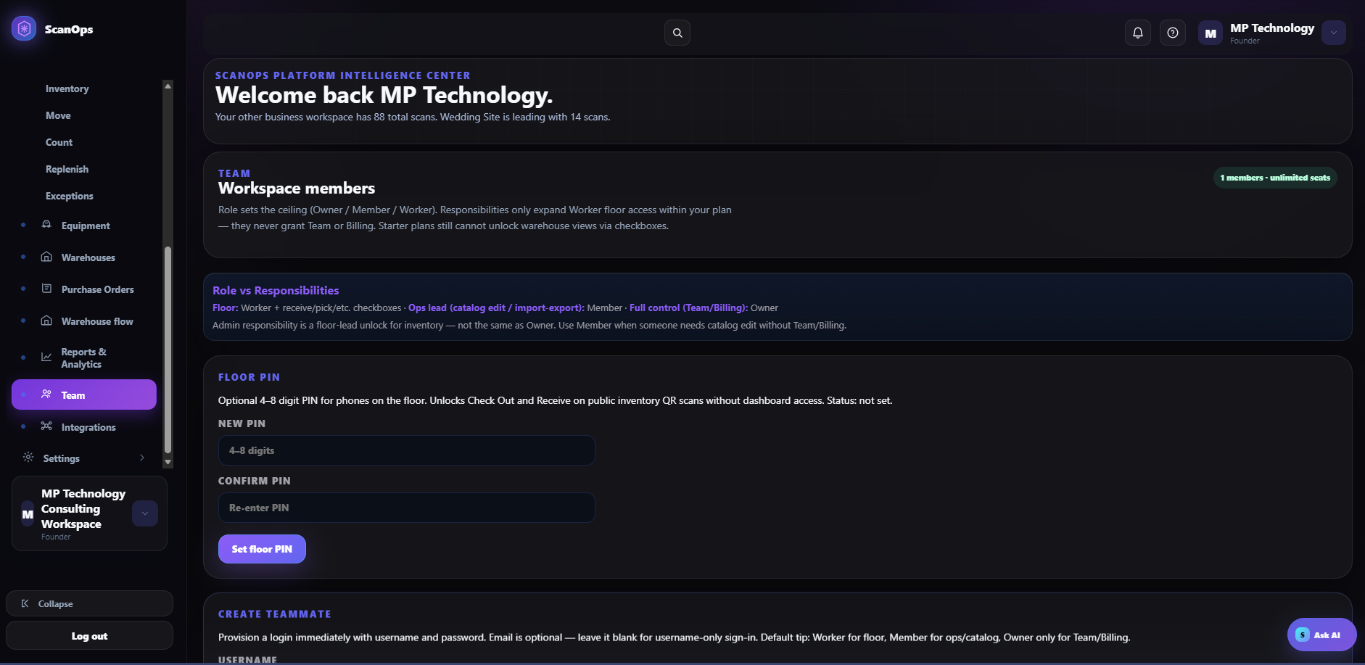
Team page: role hierarchy, Floor PIN, and teammate provisioning entry point.

IMMEDIATE ACCOUNT

2. Create a teammate login
- Open Team and scroll to Create Teammate.
- Enter a unique username using the organization’s naming standard.
- Set a temporary password with at least 8 characters, 1 number, and 1 special character.
- Enter an email when recovery or email login is required; otherwise leave it blank for username-only sign-in.
- Select Worker, Member, or Owner using the role decision rule.
- For a Worker, select only the required responsibilities. Do not select Admin merely for convenience.
- Enter notes such as shift, site, zone, manager, or temporary access end date.
- Review the seat limit and all permissions, then create the teammate.
- Deliver credentials through an approved secure channel and require the user to sign in and change the temporary password when supported.
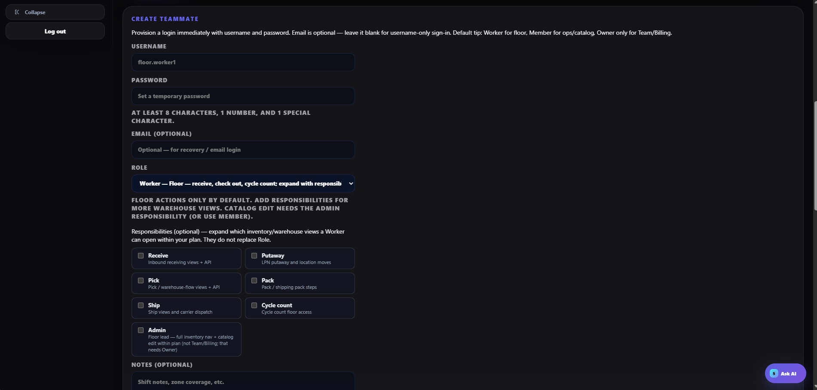
Create Teammate: username, temporary password, optional email, role, and responsibilities.
CREDENTIAL CONTROL
Never place passwords in Notes, email subject lines, shared chat rooms, tickets visible to broad groups, or printed floor instructions.

INVITATION WORKFLOW

3. Invite a teammate by email
- Open Invite Teammate.
- Enter the teammate’s verified business email address.
- Select the role. Use Member for operations/catalog needs and Owner only for Team/Billing authority.
- Add only the required responsibilities and optional work notes.
- Select Create invite link.
- Send the invite through an approved channel to the intended recipient only.
- Confirm the invite appears under Pending Invites and reserves a seat.
- After acceptance, verify the person appears under Active Members with the correct role and responsibilities.
- Cancel or replace expired, incorrect, or no-longer-needed invitations.
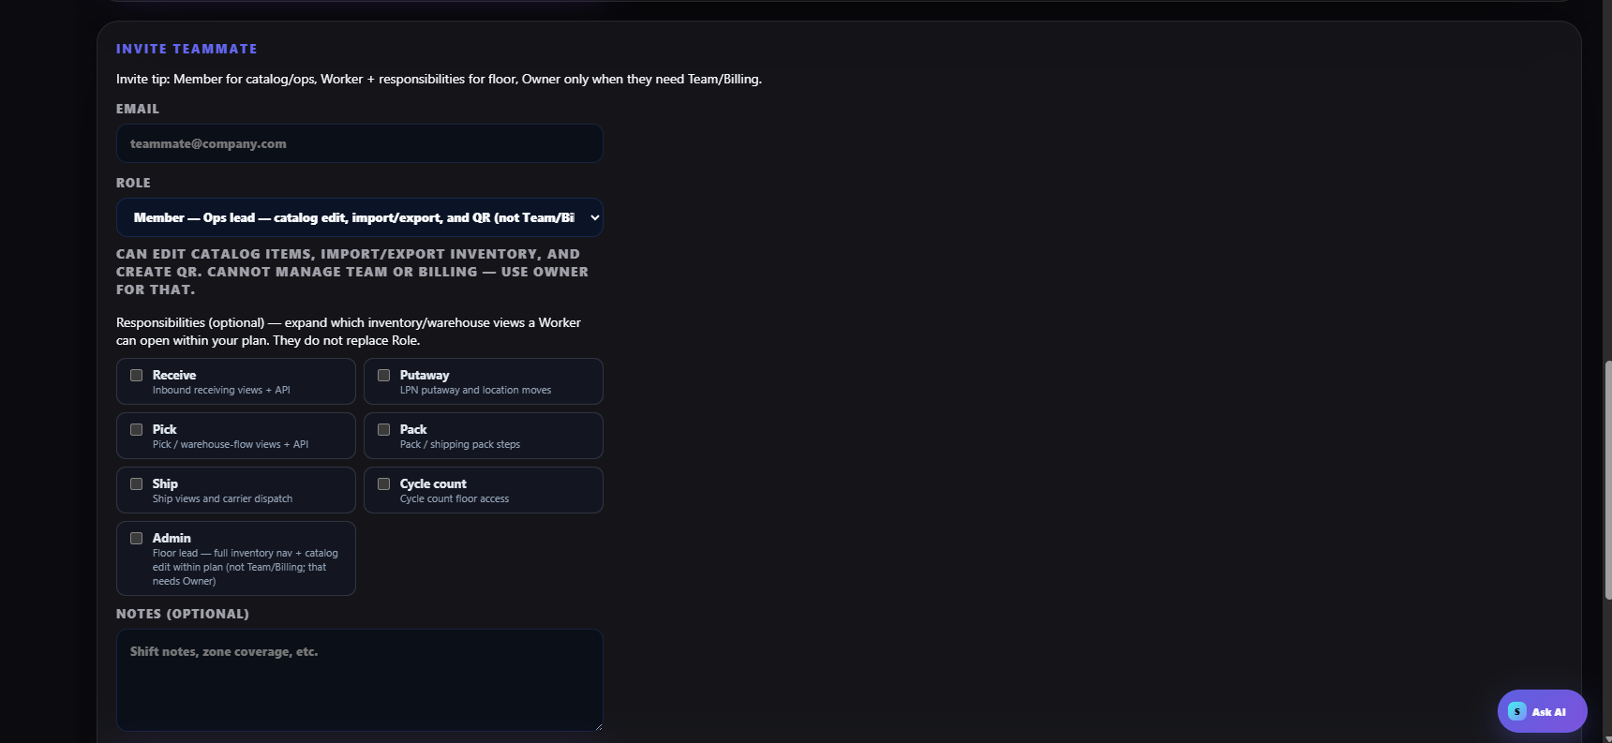
Invite Teammate: email, role, warehouse responsibilities, and notes.

Seat control
Check plan capacity before creating accounts or links. Pending invitations reserve seats until accepted or expired, and plan features still limit what responsibilities can unlock.

FLOOR PIN

4. Add an approved shared floor device
The Floor PIN is an optional 4–8 digit code for approved shared phones on the floor. It unlocks Check Out and Receive on public inventory QR scans without granting dashboard access.
- Confirm the device is organization-owned or formally approved, secured by device passcode, updated, and assigned to a site or work area.
- On Team, enter a new 4–8 digit Floor PIN and re-enter it in Confirm PIN.
- Select Set floor PIN.
- Do not use an employee number, site address, repeated digits, or another obvious value.
- On the floor device, scan an approved inventory QR and test only the intended Receive or Check Out action.
- Confirm the PIN does not grant dashboard, Team, Billing, catalog, or unrelated warehouse access.
- Record the device identifier, site, custodian, activation date, and next review date in the approved device register.
PIN HANDLING
Share the Floor PIN only with authorized floor users. Do not post it on the device or wall. Change it immediately after suspected exposure, device loss, staffing changes, or according to the security schedule.
Floor PIN supports limited public inventory QR actions on approved phones.

ACCESS LIFECYCLE

5. Verify, review & remove access

Provisioning test
- Have the teammate sign in with their own account or test the approved device workflow.
- Confirm required screens/actions are available.
- Confirm Team, Billing, catalog, export, admin, or warehouse functions outside the assignment remain unavailable.
- Complete one controlled transaction and verify the correct actor or device activity appears in history/audit records.
- Record supervisor acceptance.

Routine access review
- Review Active Members and Pending Invites at least monthly.
- Compare roles and responsibilities to current job duties, site, shift, and plan.
- Remove unnecessary Admin, Member, or Owner privileges promptly.
- Review Floor PIN devices, custodians, and last use.
- Confirm temporary access has an owner and expiration date.

Offboarding or lost device
- Disable or remove the teammate’s access immediately at separation or role change.
- Cancel unused pending invites.
- Rotate the Floor PIN when a shared device is lost, reassigned, or exposed.
- Recover organization devices and revoke local sessions where supported.
- Review recent activity and escalate suspicious actions.
- Document completion and retain the audit record.

REFERENCE

6. Completion checklist & troubleshooting

Provisioning checklist
☐ Manager approval confirmed
☐ Identity/email verified
☐ Seat available
☐ Lowest suitable role selected
☐ Only required responsibilities selected
☐ Temporary password delivered securely or invite sent to verified email
☐ Login/device test passed
☐ Excess access confirmed blocked
☐ Active member or pending invite status verified
☐ Review/offboarding owner and date recorded

Common issues
- Cannot access a warehouse view: verify the role ceiling, responsibility, plan, and workspace.
- Invite not received: confirm the email, pending status, spam controls, and expiration before recreating.
- Invite used by the wrong person: revoke access and issue a new invite after identity verification.
- Seat unavailable: remove expired invites or inactive users only after approval; do not reuse another person’s account.
- Floor PIN rejected: verify the PIN was saved, use the correct workspace/QR, and rotate rather than repeatedly sharing it.
- Too much access: reduce responsibilities or role immediately and test again.
ACCEPTANCE STANDARD
Every person has an individual identity or approved limited device method; access matches job need; excess privileges are blocked; and activation, review, and removal are auditable.

