STANDARD OPERATING PROCEDURE

Configure Workspace Branding
How to apply approved business identity to QR pages and exports while preserving readability, domain control, and change approval.
PURPOSE
Create a consistent, approved brand experience using the business name, logo, and primary color, with a validated preview before release.

Applies to
- Workspace Owners and authorized brand administrators
- Marketing or communications approvers
- IT or DNS administrators supporting custom redirect domains

Before you begin
- Obtain the approved display name, current logo asset, and primary brand color.
- Confirm who approves public-facing brand changes.
- Confirm the change window when QR pages or exports are already in production.
- For a custom domain, obtain DNS administration support and an approved hostname.
CHANGE CONTROL
Branding changes can affect public QR experiences and exported materials. Make changes in an approved window and retain the prior settings or assets for rollback.

ASSET READINESS

1. Prepare the brand assets

Business name
- Use the approved customer-facing name, not an internal project label.
- Confirm spelling, capitalization, trademark symbols, and punctuation.
- Keep the name short enough to display clearly in QR pages and exports.

Logo
- Supported formats shown in the interface: PNG, JPG, SVG, or WebP.
- File size must be under 750 KB.
- Prefer a transparent-background PNG or approved SVG when available.
- Use a version with sufficient padding and legibility at small sizes.
- Remove outdated taglines, test marks, or unintended background blocks.

Primary color
- Use the approved digital color value.
- Choose a color that remains distinguishable against the interface background.
- Verify text, borders, buttons, and QR-related elements remain readable.
- Do not use color alone to communicate status or instructions.
ASSET SECURITY
Use only organization-approved files and hosted URLs. Do not use personal file-sharing links, temporary URLs, or unverified third-party assets.

CONFIGURATION

2. Apply and preview branding
- Open Settings → Branding.
- Enter the approved business name.
- Choose one logo method: enter the approved Hosted logo URL or upload the approved file.
- If uploading, confirm the format and size meet the displayed requirements.
- Select the approved Primary color.
- Review the Brand preview for logo rendering, business name, spacing, color, and contrast.
- Check the preview at normal and narrow/mobile widths when possible.
- Select Save branding only after approval and preview checks are complete.
- Open a representative QR page and export to verify the saved result outside the settings screen.
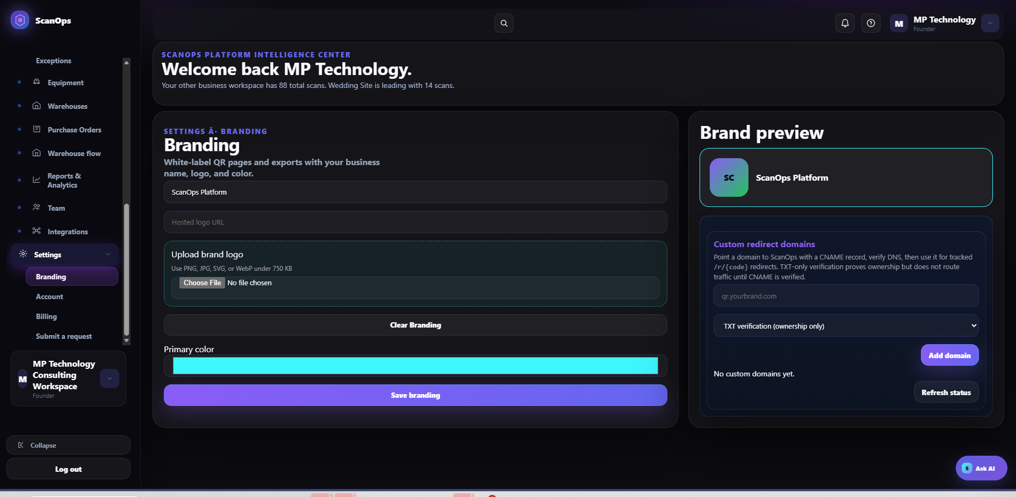
Settings → Branding: business identity, logo, primary color, preview, and custom redirect domains.
ACCEPTANCE CHECK
The preview and live sample must show the correct business name, undistorted logo, approved color, and readable content with no clipping or low-contrast text.

OPTIONAL DOMAIN

3. Configure a custom redirect domain
Custom domains support branded tracked-code redirects. DNS ownership verification and traffic routing are separate controls.
- Choose an approved hostname such as qr.yourbrand.com. Do not enter a full path or an unrelated production hostname.
- Coordinate with the DNS administrator before adding records.
- Enter the domain in Custom redirect domains.
- Select the required verification method shown in the interface and select Add domain.
- Publish the exact DNS record supplied by the platform.
- Use Refresh status after DNS propagation and confirm ownership verification.
- For tracked redirects to route, confirm the required CNAME record is present and verified.
- Test a noncritical tracked QR from an external network before production use.
- Document hostname, DNS owner, record values, verification date, and tester.
DNS DISTINCTION
TXT verification proves ownership but does not route traffic. A verified CNAME is required before tracked redirect traffic can use the branded domain.

Do not proceed when
- The hostname is already used by another service.
- DNS ownership or change approval is unclear.
- Certificate, verification, or CNAME status is incomplete.
- The test redirect fails, loops, shows a certificate warning, or reaches the wrong workspace.

LIFECYCLE CONTROL

4. Clear, change, or roll back branding

Update branding
- Capture the current display name, logo source/file, primary color, domain status, and live sample.
- Apply the approved change and review the preview.
- Save, then verify representative QR pages and exports.
- Retain the prior asset and configuration reference for rollback.

Clear branding
- Confirm written approval to remove white-label identity.
- Select Clear Branding.
- Verify the preview returns to the expected default.
- Check representative QR pages and exports for unintended remnants.
- Document the reason, approver, and completion date.

Rollback
- Restore the last approved name, logo, and primary color.
- Recheck custom-domain routing and certificate status.
- Retest QR pages and exports.
- Notify affected teams when printed or published materials may show a different brand state.
WARNING
Do not delete or repurpose DNS records during a branding-only rollback without IT approval. Existing printed tracked QRs may still depend on the domain.

RELEASE CHECK

5. Verification checklist & troubleshooting

Final checklist
☐ Approved business name entered
☐ Logo format and size verified
☐ Logo displays without distortion
☐ Primary color matches approved value
☐ Text and controls remain readable
☐ Brand preview approved
☐ Representative live QR page tested
☐ Representative export tested
☐ Custom domain ownership verified when used
☐ CNAME routing verified when used
☐ Change and rollback details recorded

Common issues
- Logo does not load: verify file type/size, URL accessibility, and that the asset is not behind authentication.
- Logo appears cropped or distorted: use the approved aspect ratio and add transparent padding rather than stretching.
- Color reduces readability: select an approved accessible alternative and retest contrast.
- Domain stays unverified: confirm the exact DNS name/value and allow for provider propagation before refreshing.
- Ownership verified but redirects fail: check the CNAME record and routing status; TXT alone does not route traffic.
- Old branding remains: refresh the live page, verify the correct workspace, and retest after cache propagation.
COMPLETION STANDARD
Branding is released only when the settings preview, representative live QR experience, exports, and any custom redirect domain all match the approved brand package.

