STANDARD OPERATING PROCEDURE

Inventory & Warehouse Operations
A controlled, QR-first process for warehouse setup, inventory receiving, LPN labeling, putaway, stock control, transfers, fulfillment, and audit review.

OPERATING PRINCIPLE
Every physical movement must be reflected in ScanOps at the time it occurs. Location quantity is the source of truth; labels identify stock but do not replace a completed transaction.

Document control
Owner | Warehouse Operations
Applies to | Inventory, warehouse, purchasing, fulfillment, and supervisors
Review cycle | Quarterly and after any workflow or label-setting change
System area | Inventory Command Center / Warehouse Flow

Outcome
- Accurate SKU, LPN, location, and on-hand balances.
- Traceable receiving, putaway, transfer, adjustment, pick, pack, and ship events.
- Readable barcode and QR labels linked to the correct inventory record.
- Documented exceptions, shift handoffs, and audit-ready transaction history.

START HERE

1. Scope, roles & control points

Roles
Role | Primary duties | Approval / control
Administrator | Warehouse, location, LPN, label, user, and carrier setup. | Approves configuration changes.
Receiver | PO/ASN receipt, inspection, quantity, LPN creation. | Escalates variance or damage.
Warehouse operator | Putaway, moves, picks, counts, packing. | Scans both source and destination.
Inventory controller | Adjustments, transfers, reconciliation, reporting. | Reviews preview and reason.

Required controls
- Use unique SKUs, warehouse codes, location codes, and LPNs.
- Keep forklifts, fleet, tools, and equipment assets under Equipment—not inventory stock.
- Never change a balance to “make it look right.” Use Count or Adjust with a reason and supporting reference.
- Preview bulk imports and adjustments before applying them.
- Do not print or apply a label until its data and scan result are verified.
STOP AND ESCALATE
Stop for unknown SKU, duplicate identifier, damaged/short/over receipt, wrong warehouse, negative balance, unreadable label, failed scan, or unexplained variance.

Preferred lifecycle
PO → Receive → Inspect → Generate LPN → Print → Putaway → Pick → Pack → Ship. Every step writes movement history.

FOUNDATION

2. Configure warehouses and locations

Create a warehouse
- Open Inventory Command Center and confirm Warehouse Mode is enabled.
- Select Warehouses. Enter a unique warehouse name, code, address, and Active status.
- Select Create warehouse, then confirm it appears in the active warehouse count.
- Do not receive stock into the site until its usable locations are created.
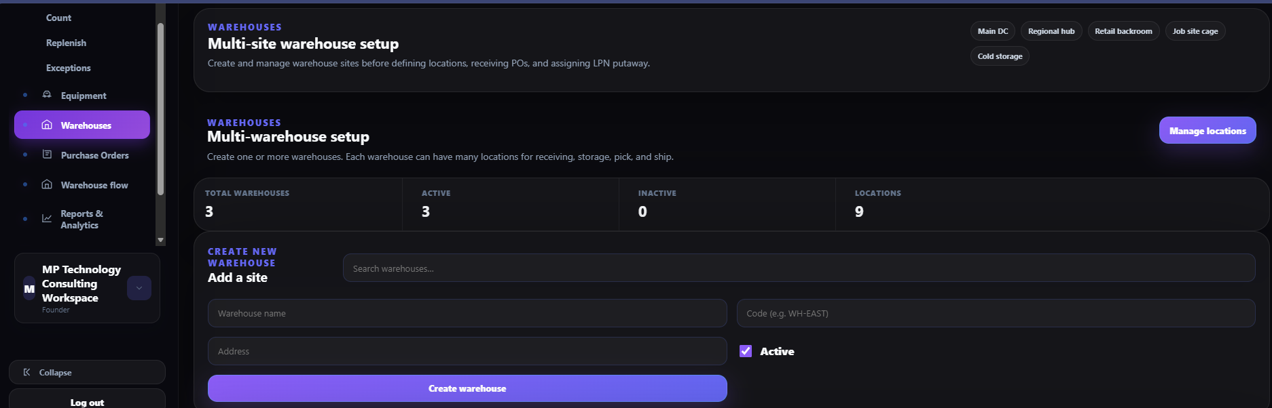
Warehouse setup: create and manage each physical site.

FOUNDATION

Create storage and workflow locations
- Open Locations and select the warehouse.
- Enter a unique location code using the approved convention (for example, A-01-01).
- Complete zone, aisle, bay, shelf/bin, and storage type as applicable.
- Set Allow mixed LPN and Free location only according to site policy.
- Select Add location; print and scan-test the location label before use.
- Use Bulk Import locations only with the approved template and a preview review.
NAMING STANDARD
Location codes should be short, unique, scannable, and physically posted. Never reuse an old code for a different physical position.
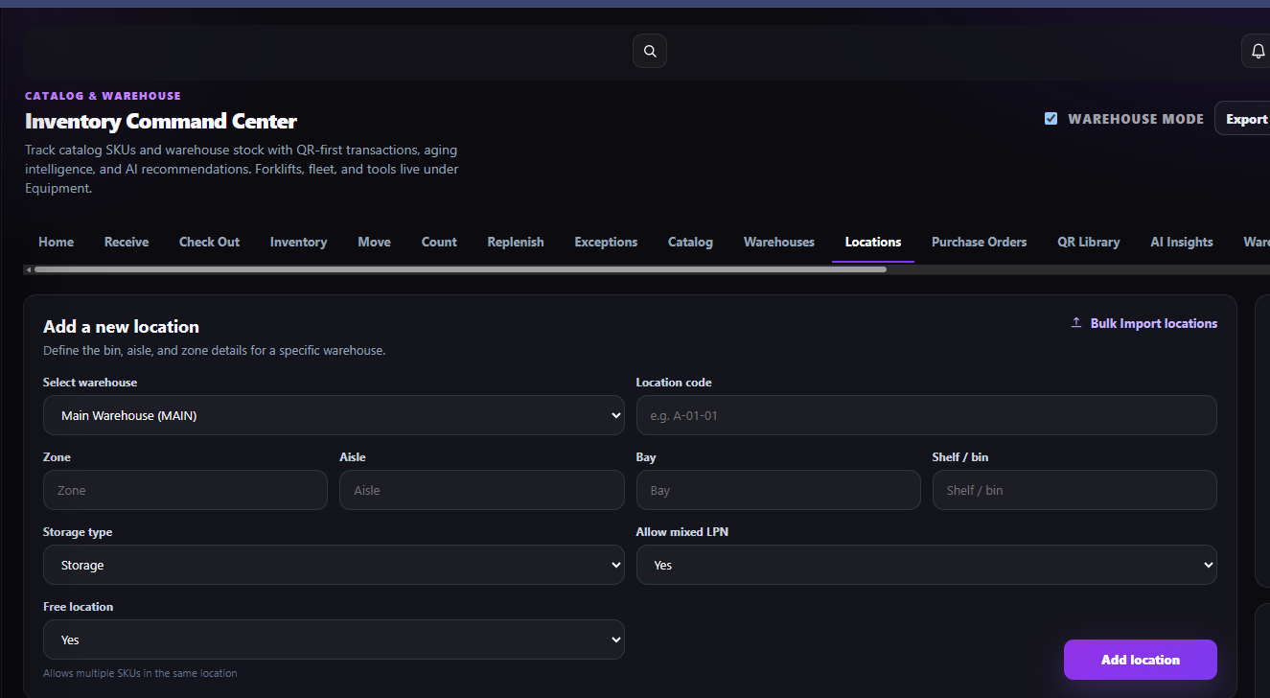
Location setup: warehouse, location code, physical hierarchy, and mixing controls.

MASTER DATA

3. Build the catalog and purchasing records

Import or maintain inventory
- Download the tailored template when adding many items.
- Choose CSV or Excel, select duplicate handling, and upload the file or paste rows.
- Preview import. Correct missing SKU, name, warehouse/location, unit, or quantity errors.
- Import records only after the valid row count and duplicate treatment are confirmed.
- Export CSV/XLSX after major updates as a control copy.
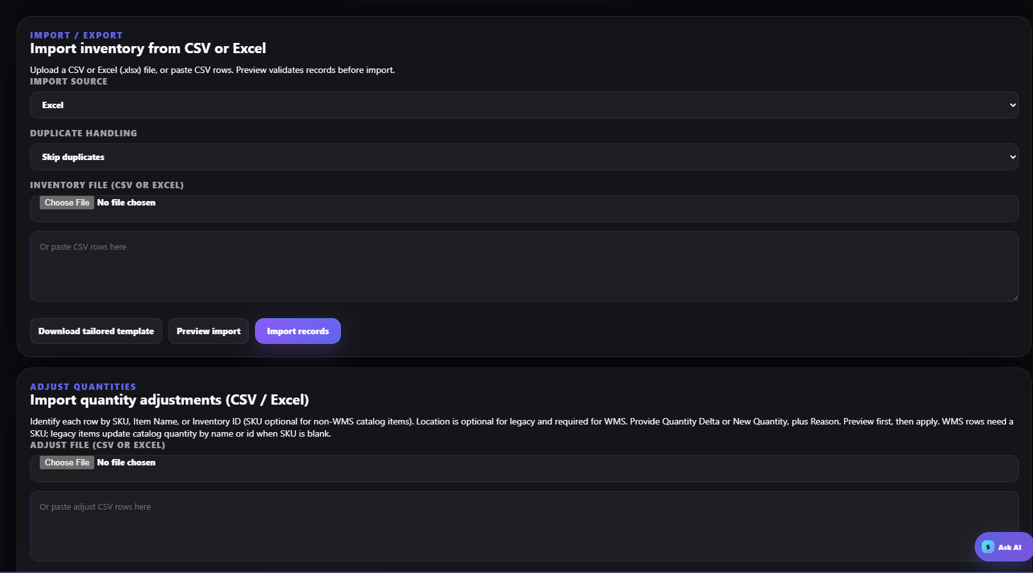
Import inventory and quantity adjustments using preview-first controls.

INBOUND PLANNING

Create and manage purchase orders
- Open Purchase Orders and select the correct template: Standard, Detailed, Blanket/release, or Service/non-stock.
- Download CSV, Excel, or PDF; complete supplier, PO number, lines, SKU, quantities, and terms as required.
- Import or paste the completed PO and verify its status is Open.
- Use Open Receive workflow when the delivery arrives. Closed POs remain in history but leave the active receive queue.
TEMPLATE CHOICE
Use Standard for routine SKU receiving; Detailed when ship-to/bill-to/terms are required; Blanket for releases; Service/non-stock only when no stock SKU is expected.
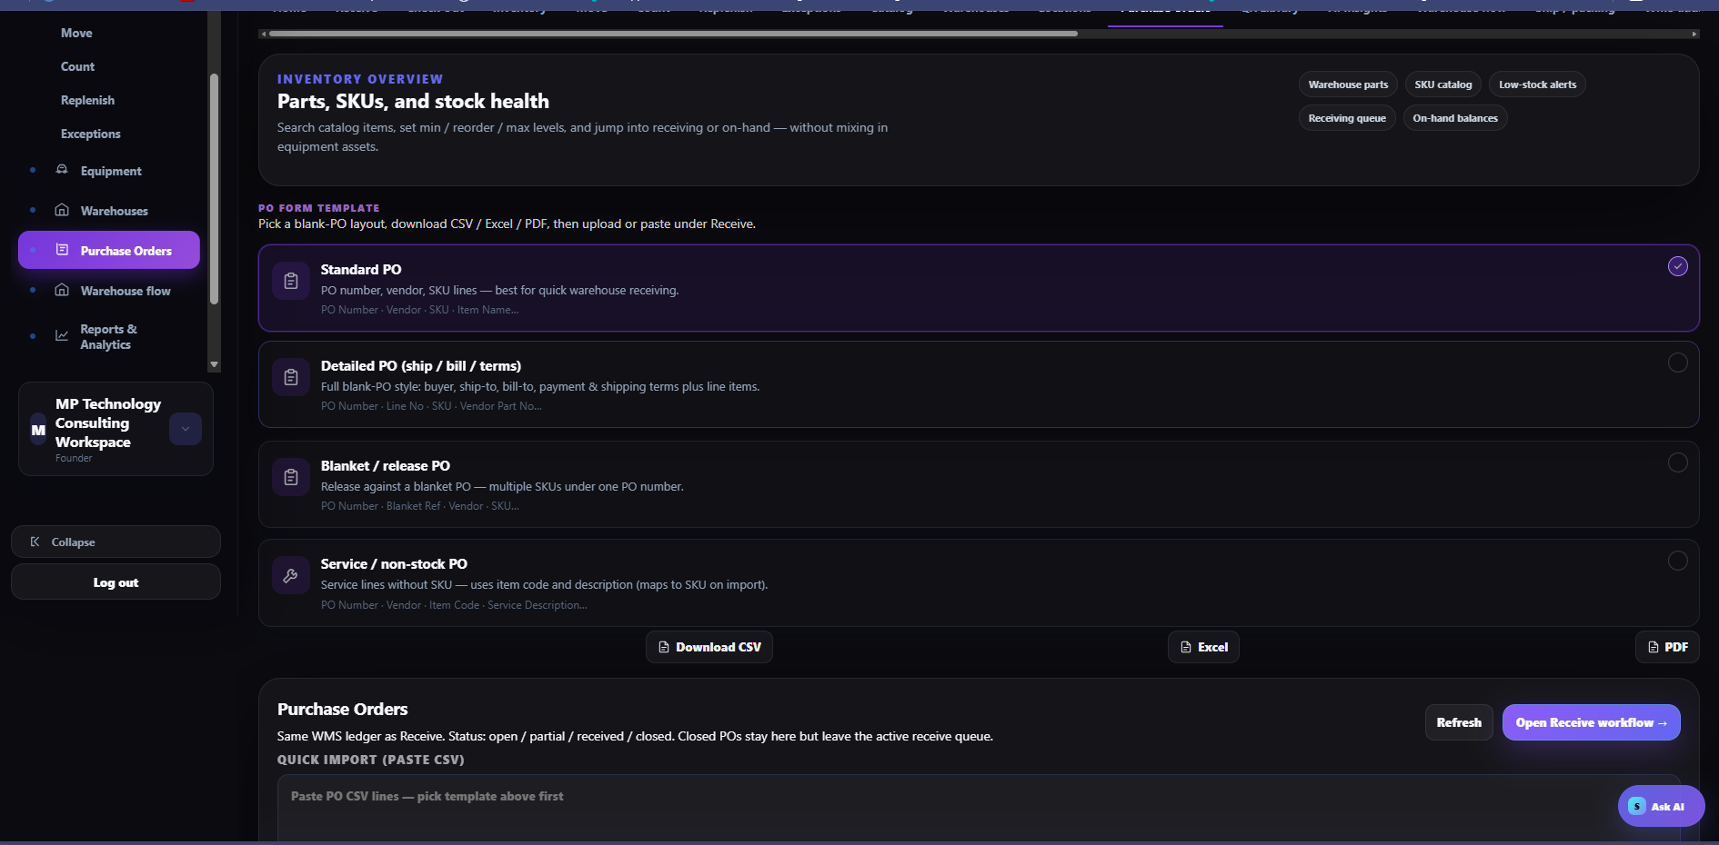
Purchase-order templates and receive-workflow entry point.

LPN CONTROL

4. Configure LPN and label standards
- Open LPN Settings before first use or whenever the label standard changes.
- Use Auto Generate unless a controlled custom or manual convention is approved.
- Select required content: LPN, PO, description, receipt date, barcode/QR, SKU, quantity, warehouse, location, lot/batch, expiration, or custom field.
- Choose one LPN per item or one per receipt according to the operation.
- Authorize multiple SKUs per LPN and mixed LPN locations only when segregation and traceability remain acceptable.
- Select 4×6 or the approved size and Both (barcode + QR) where supported.
- Review the preview and save; scan-test the first printed label.
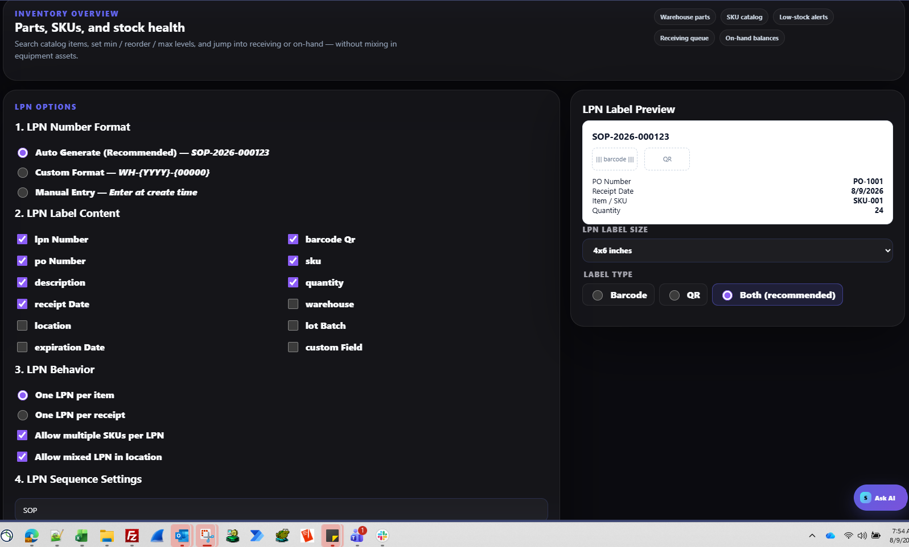
LPN numbering, content, behavior, size, and barcode/QR settings.

RECEIVING

Create an LPN
- From Create LPN, select Auto-generate, Custom format, or Manual entry according to policy.
- Enter or scan the SKU; verify item name and receiving reference.
- Enter the verified physical quantity.
- Select Create LPN once. Record the generated identifier on receiving paperwork.
- If the SKU or quantity is wrong, correct through the controlled transaction—do not reuse or hand-edit the LPN.
DEFAULT
Auto-generate is preferred because it prevents duplicate identifiers and preserves the configured sequence.
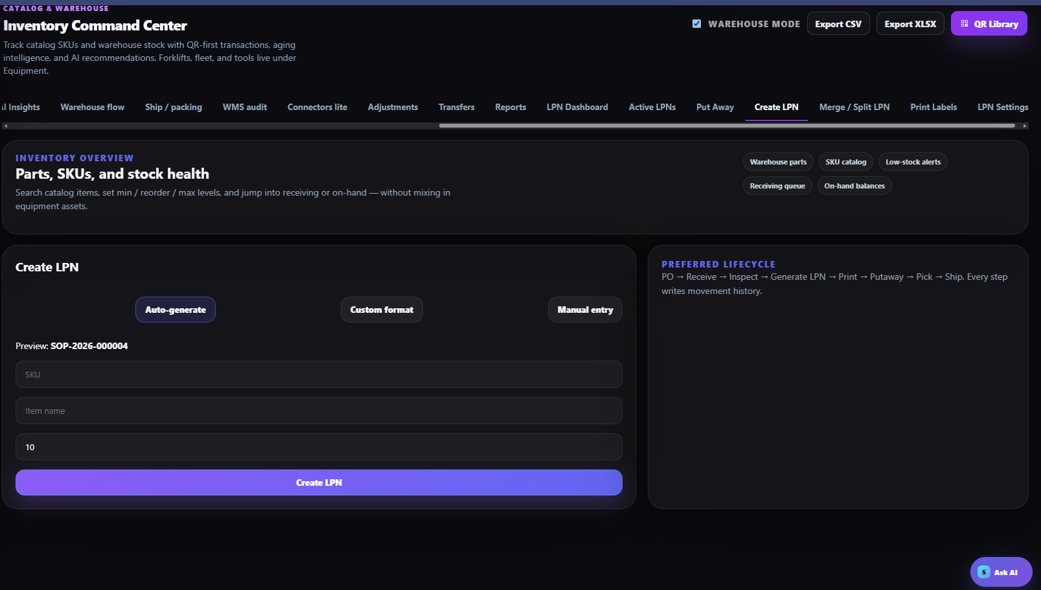
Create LPN and preferred inventory lifecycle.

LABEL CONTROL

Print and verify LPN labels
- Open Print Labels and choose Barcode, QR, or Both; Both is recommended.
- Select only the intended LPNs and verify each displayed quantity.
- Open the sheet for final layout review, then print selected labels.
- Apply the label to a clean, visible surface without covering required supplier or safety markings.
- Scan the barcode and QR with the production device. Confirm the LPN, SKU, quantity, and destination page.
- Reprint damaged or unreadable labels; never create a second LPN merely to replace a label.
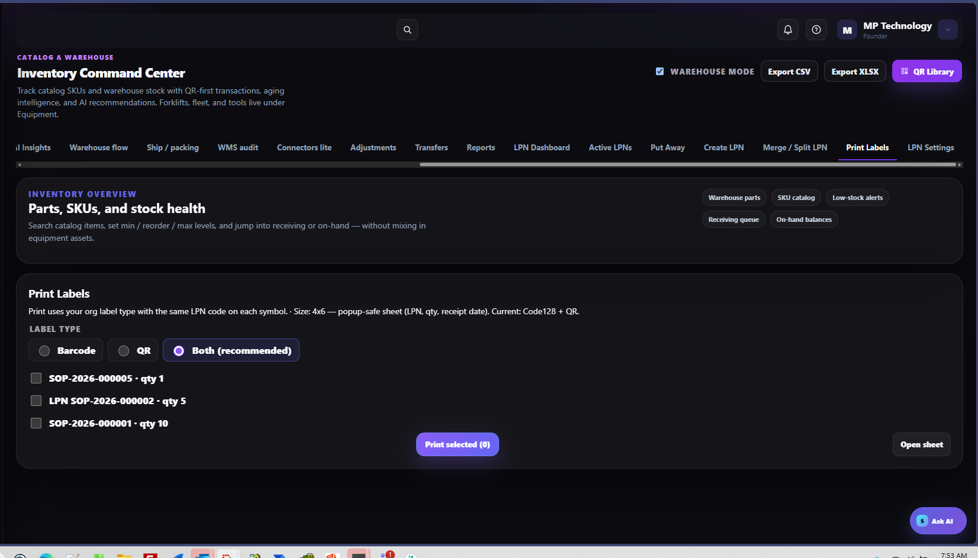
Print selected LPN labels using the approved symbol type.

WAREHOUSE EXECUTION

5. Put away, merge, and split LPNs

Put away
- Open Put Away. Scan the LPN first.
- Verify the displayed SKU and quantity, then scan the physical location label.
- Confirm the location is suitable for capacity, storage type, lot/expiry, and mixing rules.
- Complete putaway. The system location must match the physical location before the operator leaves.
- If the scan fails, do not key a guessed value; isolate the stock and resolve the label or master data.
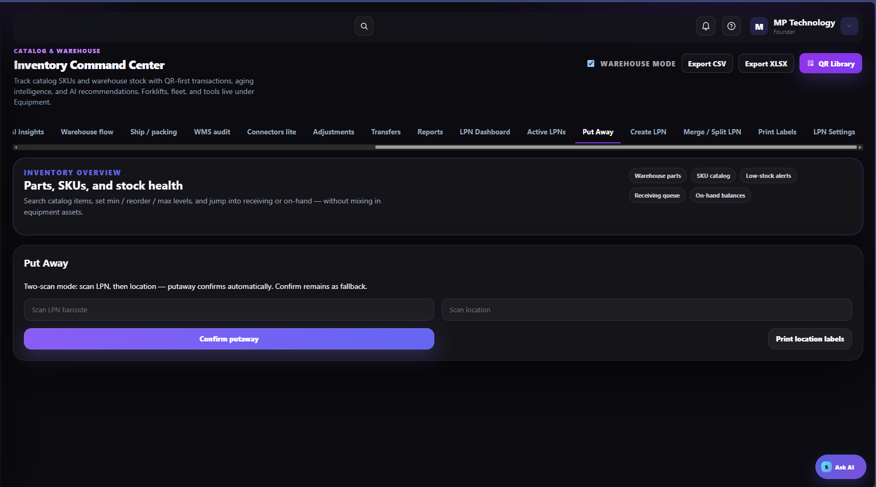
Two-scan putaway: LPN followed by location.

CONTAINER CONTROL

Merge or split LPNs

Merge
- Confirm all source LPNs are in the same authorized location and compatible for SKU, lot, expiry, and status.
- Enter the LPN codes and select Merge.
- Verify the surviving LPN quantity and retire removed labels.

Split
- Select the source LPN and enter the quantity to separate.
- Select Split and print the new LPN label.
- Apply both labels to the correct physical quantities and scan-verify each result.
DO NOT MERGE
Do not merge quarantined with available stock, incompatible lots/expiry dates, different ownership/status, or items requiring separate traceability.
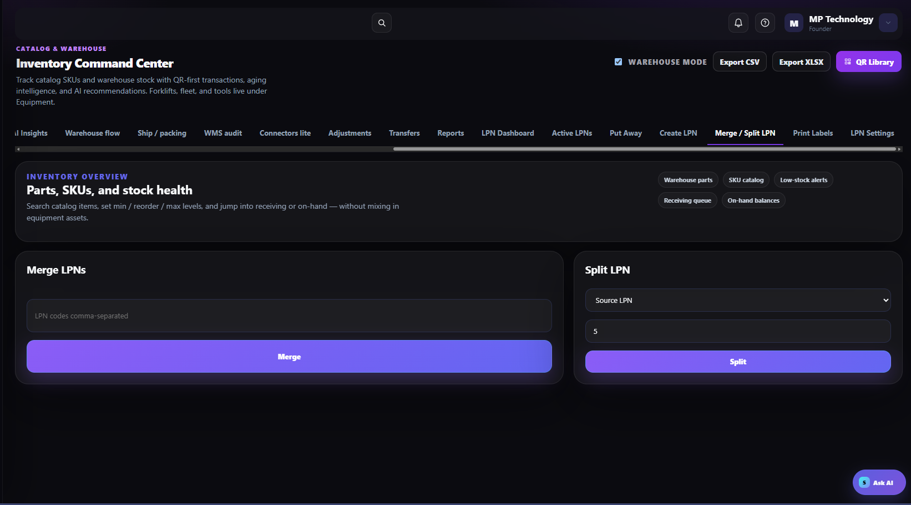
Merge and split controls in the Inventory Command Center.

STOCK ACCURACY

6. Count and adjust inventory

One-by-one adjustment
- Physically count the SKU at the location before changing the system.
- Open Adjustments and enter SKU, location, and LPN/lot/serial when applicable.
- Choose Quantity delta (+/−) or New quantity.
- Enter a specific reason and supporting reference.
- Compare current to next quantity; select Confirm & adjust only when correct.
- Escalate large, recurring, or unexplained variances to the supervisor.
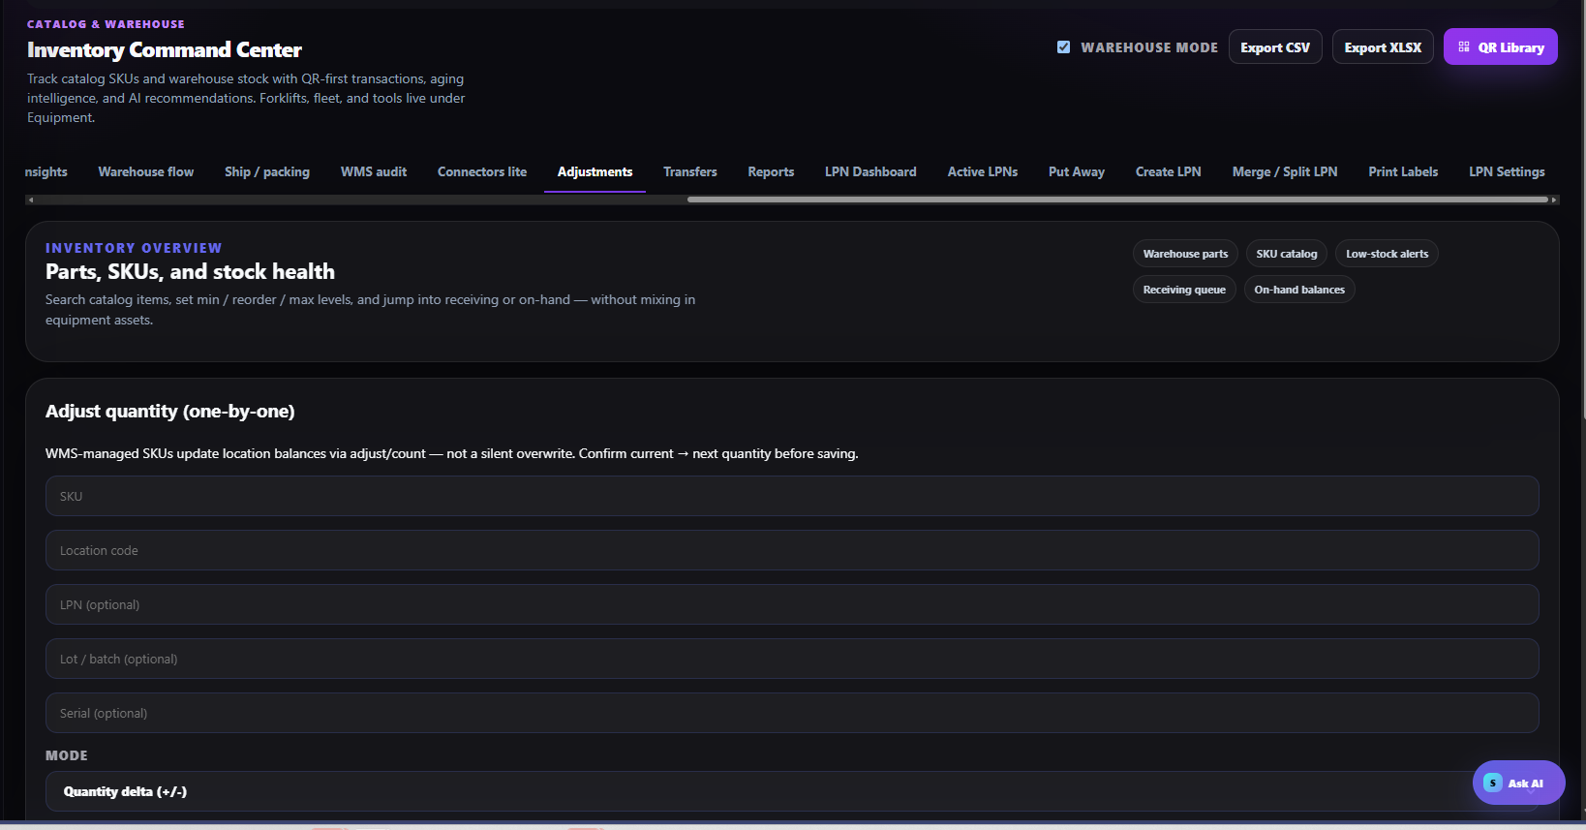
Adjustment form: identify the exact SKU and location before changing quantity.

STOCK ACCURACY

Bulk quantity adjustments
- Download the adjustment template.
- Identify each row by SKU, item name, or inventory ID. WMS rows require SKU and location.
- Provide Quantity Delta or New Quantity and a reason for every row.
- Upload CSV/Excel or paste rows, then select Preview adjustments.
- Review valid, warning, and rejected rows; correct errors before applying.
- Select Apply adjustments and retain the result report with the count or correction record.
NO SILENT OVERWRITE
Bulk tools do not replace review. A successful upload is not approval; the preview and reason are mandatory control points.
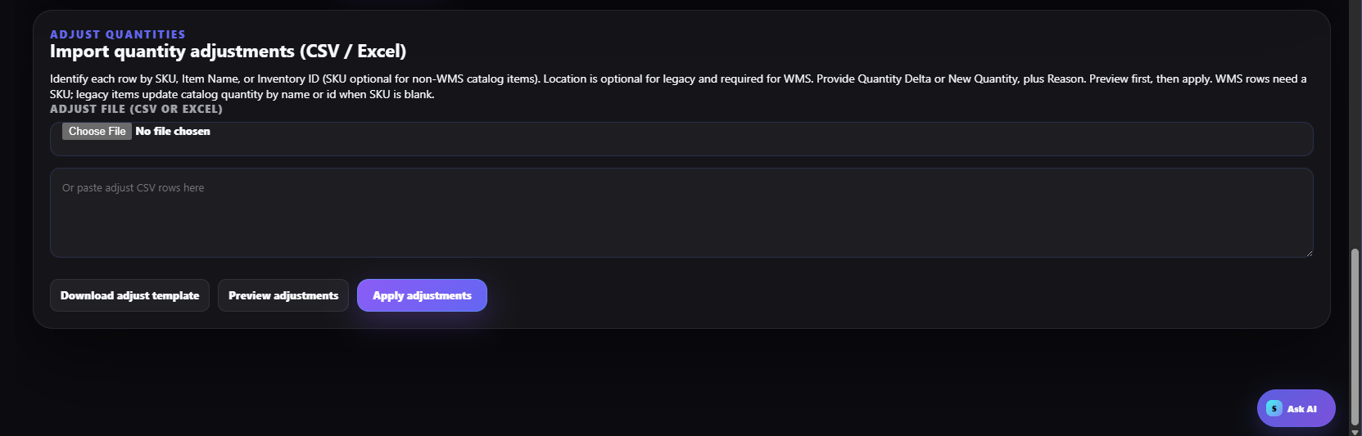
Bulk adjustment upload, preview, and apply controls.

BALANCING

7. Transfer stock between warehouses
- Open Transfers and review transfer opportunities or search the SKU.
- Confirm source available quantity exceeds committed demand and minimum/reorder requirements.
- Confirm destination need, storage capacity, and authorized location.
- Create the transfer with source, destination, SKU/LPN, quantity, and reference.
- Pick and ship from the source; receive and put away at the destination.
- Reconcile in-transit, received, short, damaged, or rejected quantities before closure.
OWNERSHIP
Source owns accuracy until shipment is confirmed. Destination owns receipt accuracy after handoff. Never adjust both sites to hide an in-transit variance.
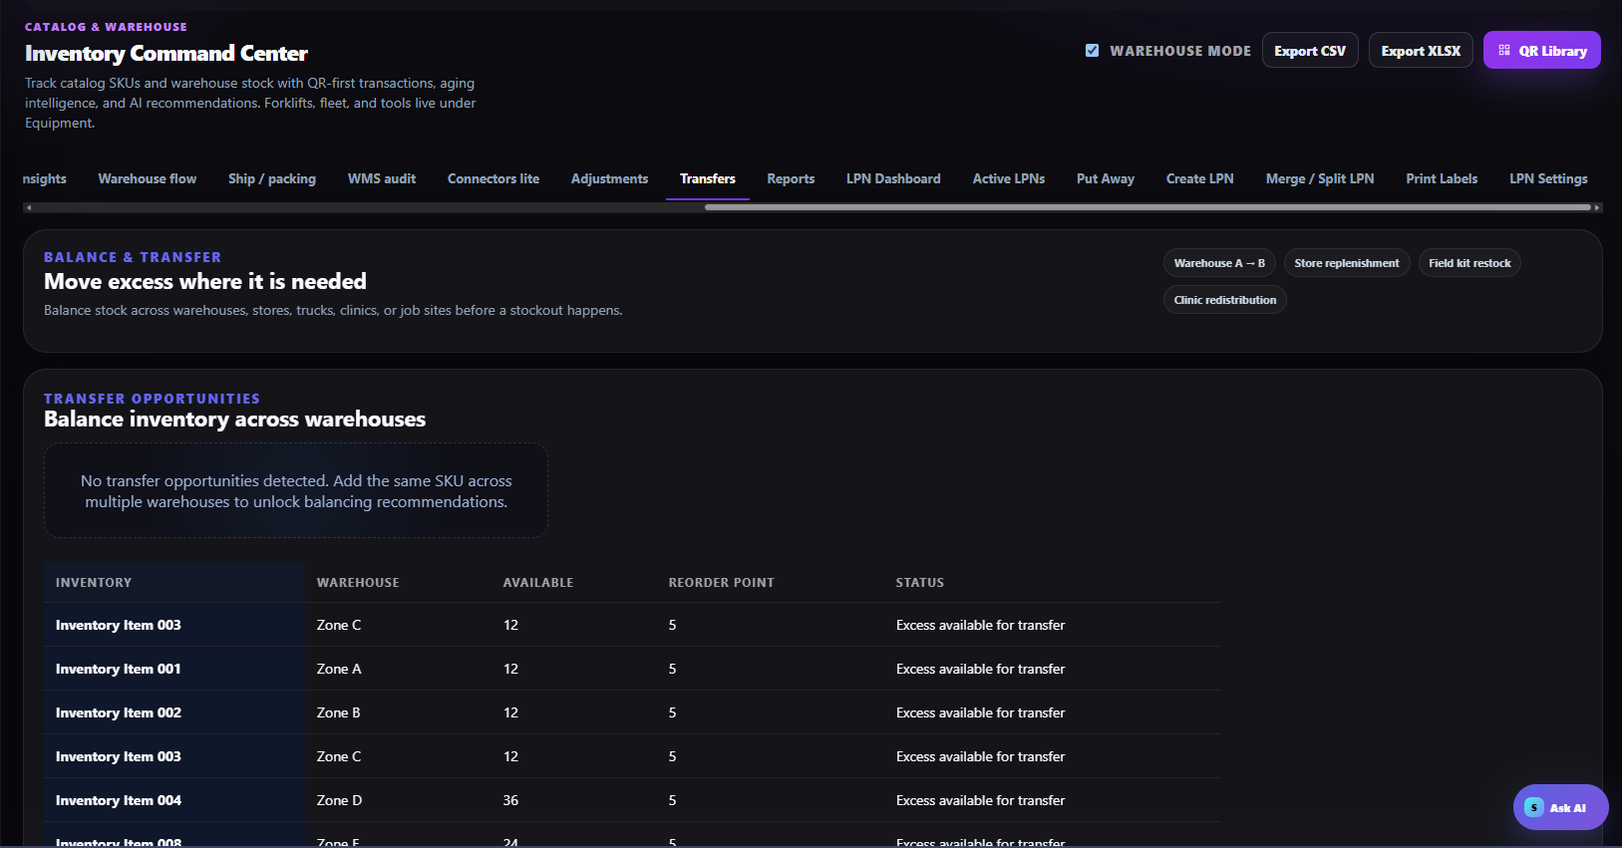
Transfer opportunities identify excess stock available for redistribution.

QR-FIRST INVENTORY

8. Generate and manage inventory QR labels

Inventory QR Library
- Open Inventory → QR Library. Use this area for shelf, bin, SKU, receiving, and pick-face labels.
- Search by name, SKU, location, or QR code; filter All items, Has QR, or Needs QR.
- Select an item and verify the scan preview shows the correct SKU, location, and available balance.
- If a label is missing or outdated, generate or replace it from the linked inventory record.
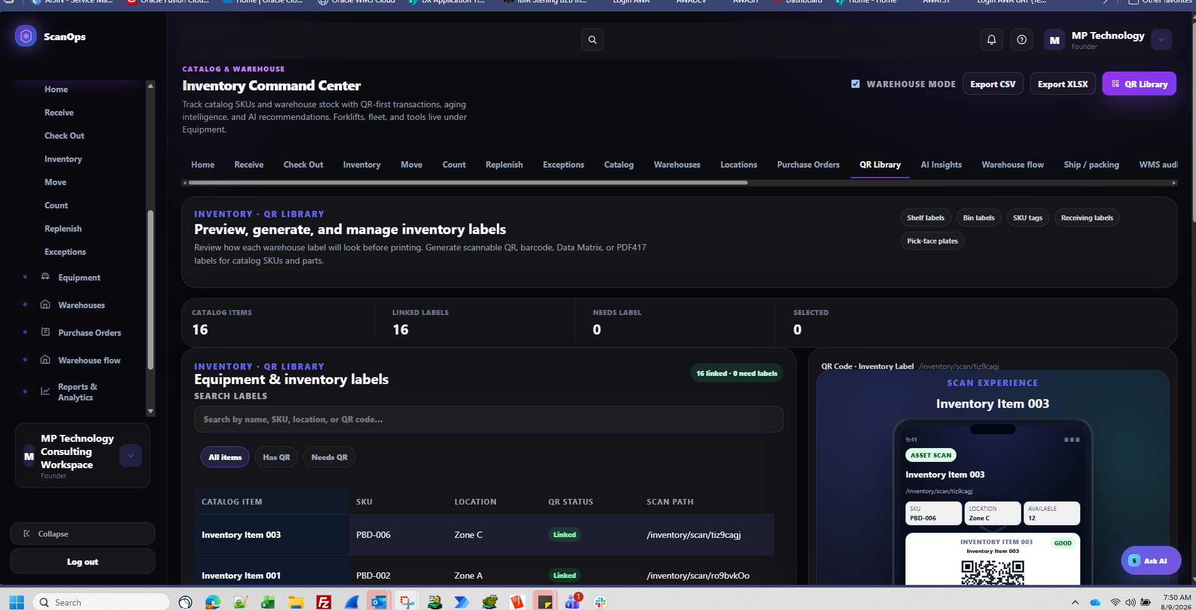
Inventory QR Library: linked status, search, item records, and scan preview.

QR-FIRST INVENTORY

Bulk QR label wizard
- Select assets/items.
- Choose the approved template.
- Preview every label for name, SKU, location, quantity, symbol contrast, and sizing.
- Generate and export only after the selected count matches the work order.
- Print, apply, and scan-test representative labels—and the first label from each printer or media batch.
SEPARATION RULE
Inventory labels live in Inventory → QR Library. Sales, marketing, and promotion codes belong in Marketing Hub; general web/campaign codes belong in QR Codes → Library.
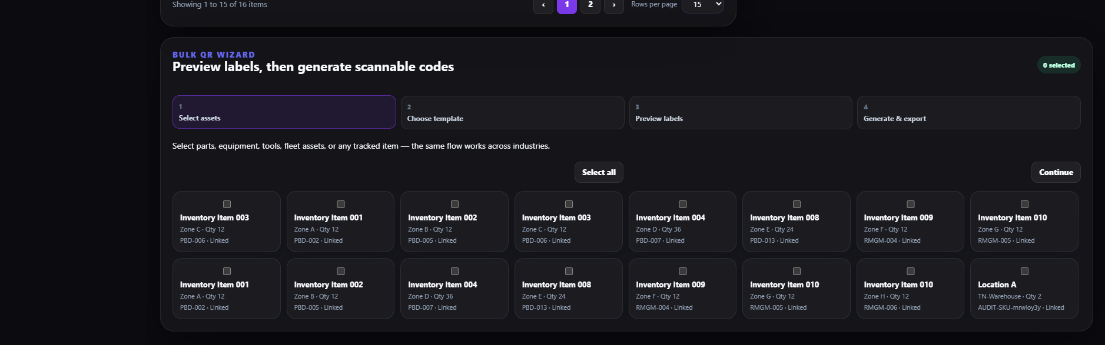
Bulk wizard: select, template, preview, generate, and export.

FULFILLMENT

9. Run the connected warehouse flow
- Create or receive the inbound ASN/PO job and record actual quantity and variance.
- Complete LPN creation and putaway.
- Create the outbound job with reference, warehouse, SKU, quantity, location, and ship-to information.
- Release a priority pick wave; scan pick source and LPN/item.
- Confirm pack, calculate rates, create/print the label or use approved manual tracking, and print the packing slip.
- Enter tracking and select Ship complete.
- Record shift handoff notes and review the audit trail for incomplete work.
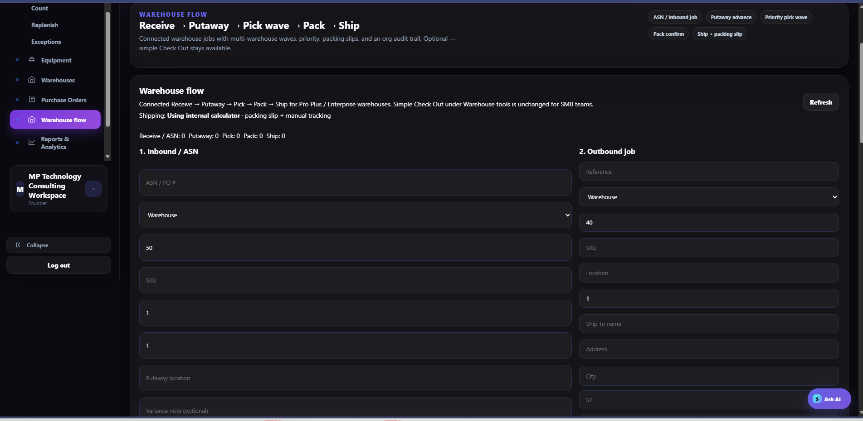
Connected flow: receive, putaway, pick wave, pack, and ship.

FULFILLMENT

Pack and ship
- Verify picked lines and quantities against the outbound job.
- Select Confirm pack, enter weight, and calculate rates when required.
- Use connected UPS/FedEx/USPS for live rates and labels, or the approved internal calculator with manual tracking.
- Create the carrier label and print the packing slip.
- Apply the correct label, enter tracking, and select Ship complete.
- Do not mark complete until the physical shipment has transferred to the carrier or approved staging process.
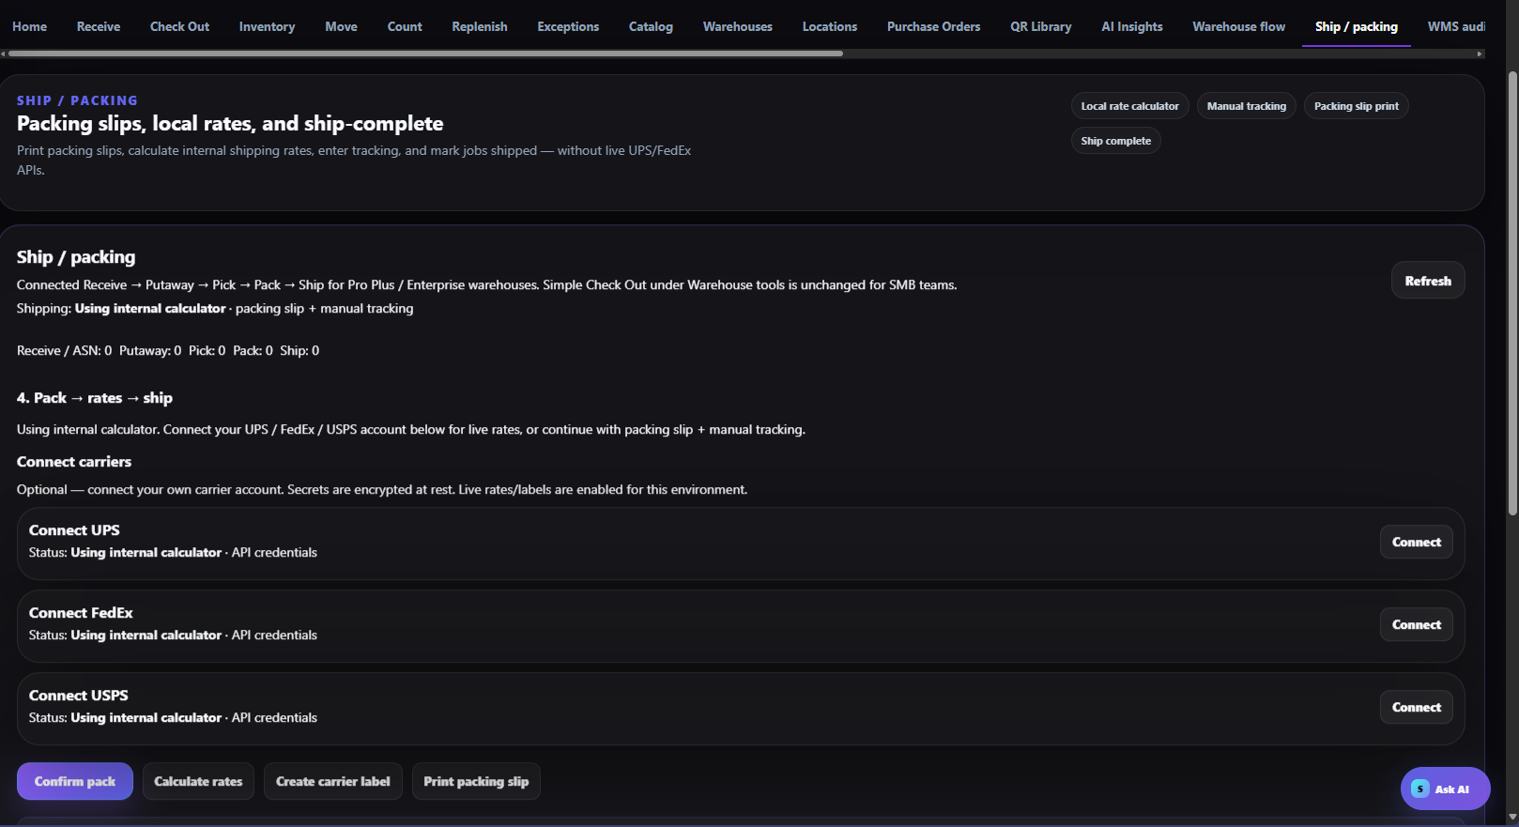
Packing, carrier connection, rate, label, and ship-complete controls.

DAILY INVENTORY

10. Follow the Inventory menu for daily work

Navigation order
Operators should work from the Inventory area and select the function that matches the physical action. The recommended operating sequence is Home → Receive → Inventory/On-Hand → Move or Check Out → Count → Replenish → Exceptions.

Home and Catalog
- Use Home to review inventory health, low stock, aging, overstock, FIFO, and putaway backlog.
- Use Catalog to create and maintain the item master. Enter name, SKU, description, category, UOM, min/max, warehouse, default location, unit cost, vendor, status, and optional linked QR/NFC.
- Create the catalog record first; add stock through Receive or Adjustments. Do not set a starting quantity in the catalog form.
- Keep forklifts, fleet, and tools in Equipment.
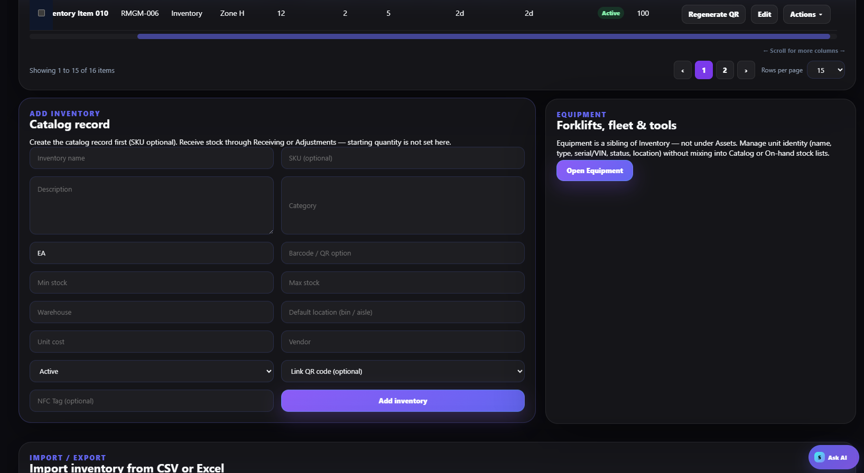
Catalog record: master data is created here; stock enters through controlled transactions.

DAILY INVENTORY

Receive inventory
- Open Receive and select or load the purchase order.
- Inspect the delivery for damage, shortage, overage, lot/serial, and item identity before posting receipt.
- Record actual accepted quantity and any exception.
- Complete Receive, generate the LPN, print and scan-test the label, then put away.
- Use Receive without PO only when policy permits; enter SKU, item name, quantity, lot/serial, and a note. The transaction creates an LPN and receive ledger entry.
- Stock becomes available at the location after putaway.
RECEIVING SEQUENCE
PO → Inspect exceptions → Receive → LPN → Putaway. Do not skip inspection or treat received stock as available before location confirmation.
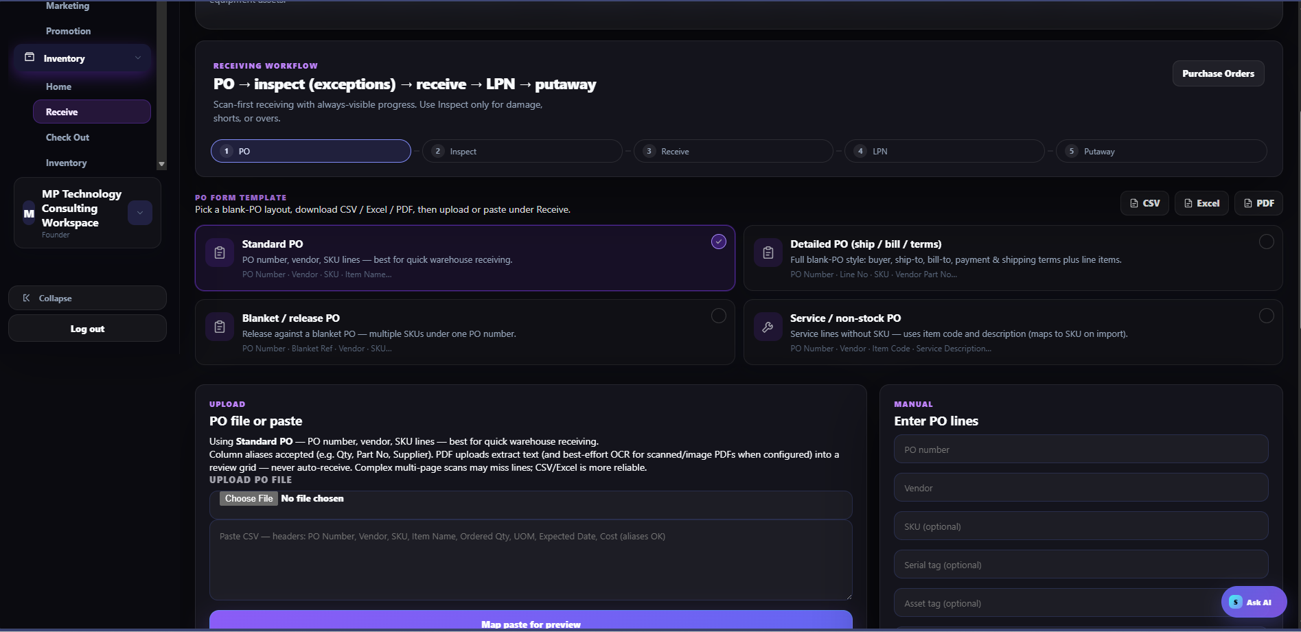
Receive workflow and PO input options.

DAILY INVENTORY

Review On-Hand and move stock

On-Hand
- Open Inventory and search by name, SKU, or location.
- Confirm location, total quantity, available quantity, and LPN before acting.
- Use Sync catalog stock to On-Hand only as an authorized reconciliation action after reviewing exceptions—not as a routine shortcut.
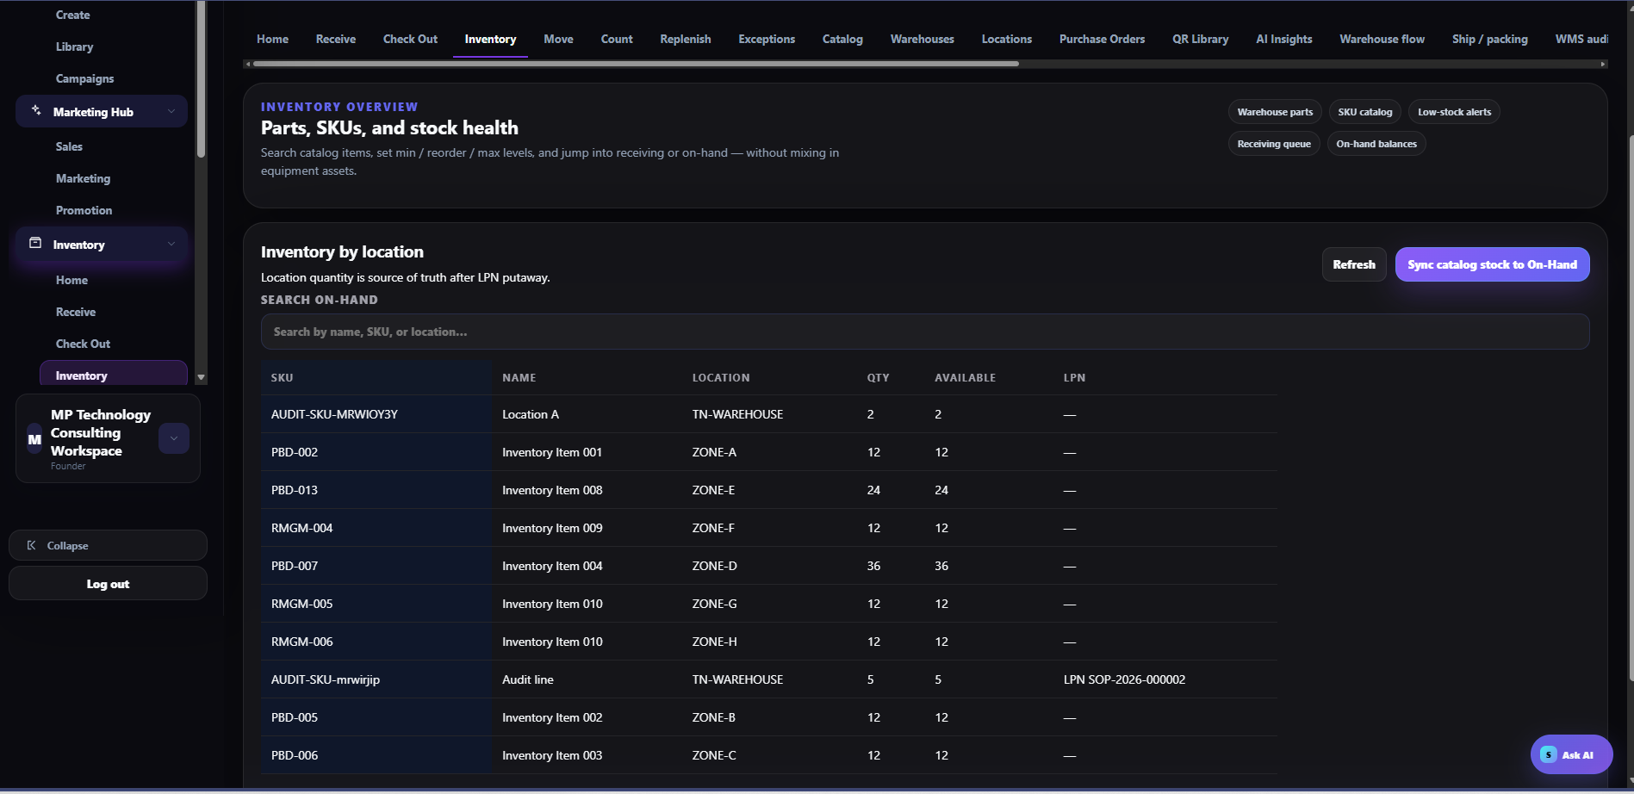
Inventory by location: location quantity is the source of truth.

Move
Use Move for internal relocation. Scan or verify the LPN/item, source, destination, and quantity. Complete the transaction before moving to the next task, then confirm the movement appears in LPN Moves.

DAILY INVENTORY

Check out stock from a location
- Open Check Out and scan the bin/location code.
- Load location contents and select the SKU.
- Enter the LPN when tracked, the quantity to remove, and a reason/note.
- Verify sufficient available quantity, then select Check Out.
- Confirm On-Hand decreased at that location and the physical quantity matches.
- Use a pack list where applicable; do not use Check Out as a substitute for a warehouse shipment when the connected outbound workflow is required.
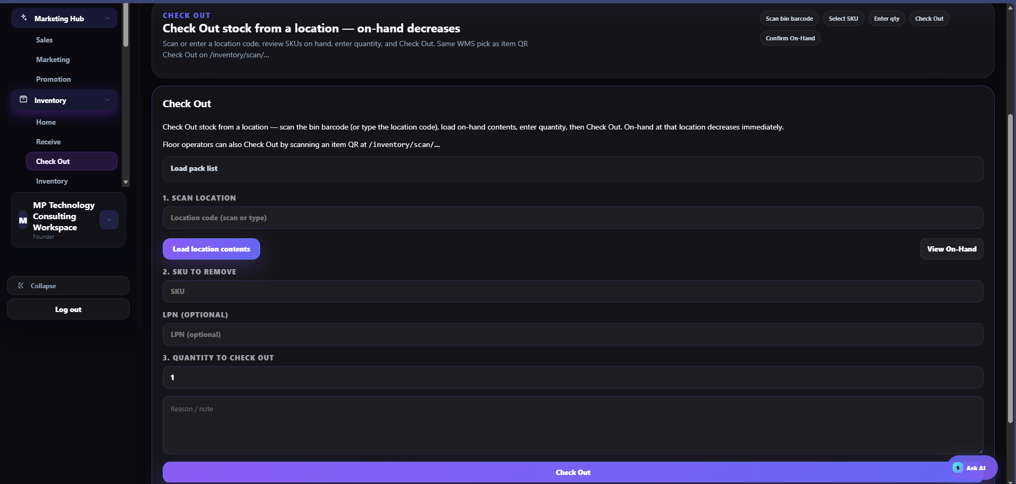
Check Out: scan location, select SKU/LPN, enter quantity, and post the removal.

DAILY INVENTORY

Cycle count and variance control
- Open Count and select Guided or Blind mode according to policy. Blind mode reduces confirmation bias.
- Create a count session with a name, location codes, and optional due date, or open an assigned session.
- Scan the location and load its contents. Count each SKU/LPN physically and enter the observed quantity.
- For advanced manual count, enter SKU, location, LPN when tracked, and counted quantity.
- If approval is enabled, a nonzero variance remains pending and On-Hand does not change until a different authorized user approves.
- Resolve rejected or unexplained variances through Exceptions and the audit trail.
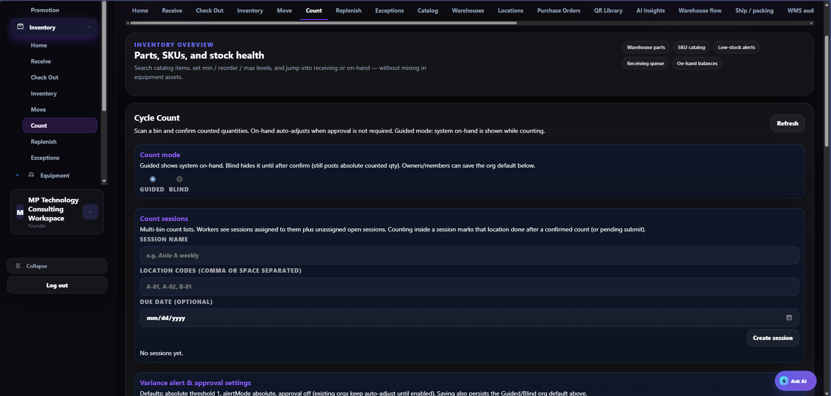
Cycle Count: count mode, sessions, locations, and variance settings.

Recommended schedule
- Class A / high velocity: weekly.
- Class B / moderate velocity: biweekly.
- Class C / low velocity: monthly.
- Critical, regulated, or high-variance stock: use the stricter local policy.

DAILY INVENTORY

Configure count alerts and reminders
- Enable variance alerts and select Absolute, Percent, or the approved alert mode.
- Set thresholds appropriate to item value, risk, and operating volume.
- Enable approval for count variances when segregation of duties is required.
- Configure in-app and email notifications.
- Set reminder cadence, day, timezone, focus locations/aisles, and class-based schedules.
- Enable automatic count sessions only after location codes and responsibilities are reliable.
- Save settings and test with a controlled count session.
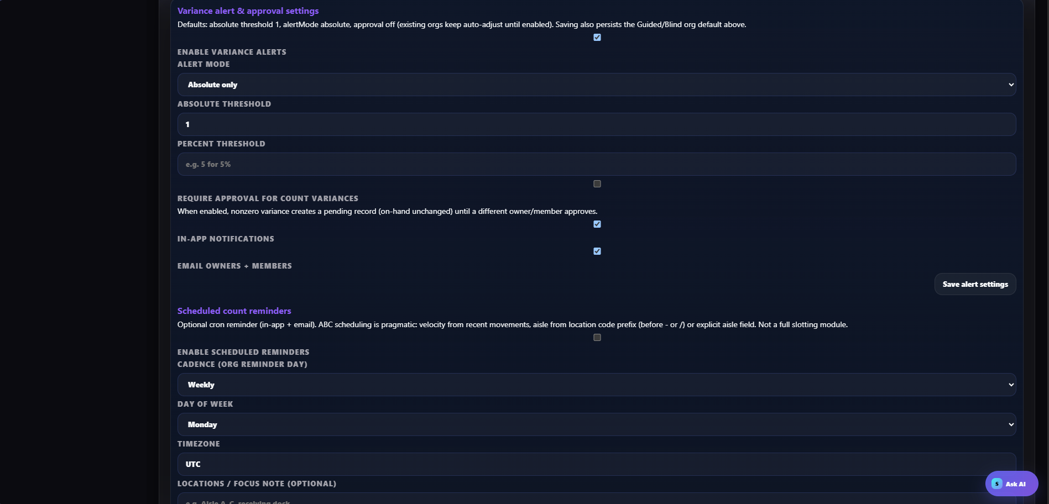
Variance alerts, approvals, notifications, and scheduled count reminders.

DAILY INVENTORY

Replenishment and exceptions

Replenish
- Review suggested replenishment based on minimum/target levels.
- Confirm demand, available source quantity, destination capacity, open receipts, and existing tasks.
- Create or assign the operator task; move the exact quantity and close the task after scan confirmation.
- If no recommendation appears, do not create stock movement without a verified need.
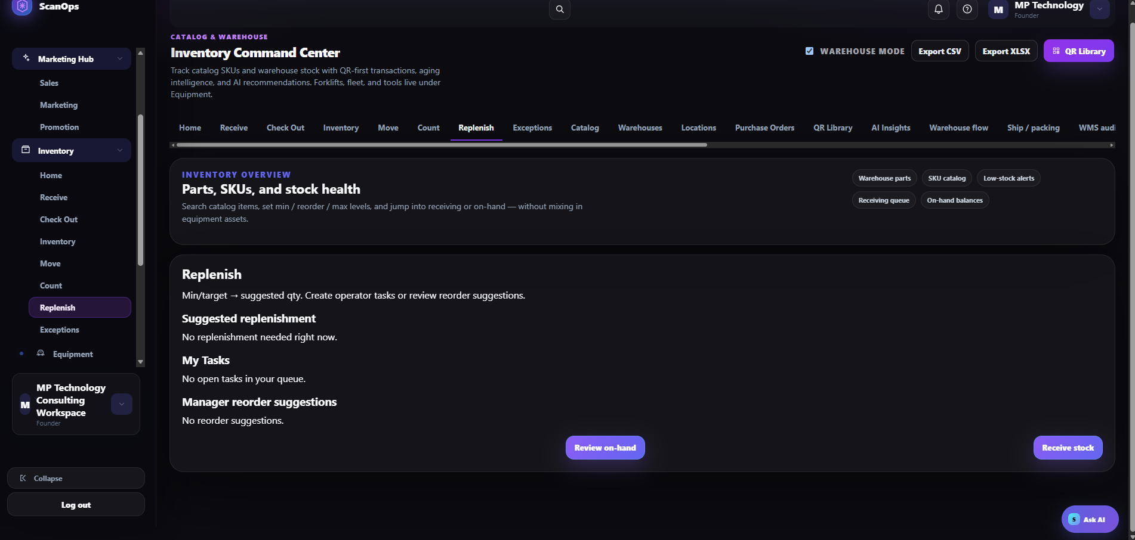
Replenishment suggestions, tasks, and manager review.

Exceptions
- Open Exceptions daily and prioritize High before Medium and Low.
- Route count variance to Cycle Count/Adjustments, receipt shortage or overage to Receiving, and unexplained activity to WMS Audit.
- Document resolution and confirm the exception closes only after the underlying inventory record agrees with physical stock.

SUPERVISOR CLOSEOUT

11. Daily review, exceptions & audit

Use AI Insights as decision support
- Review low stock and reorder suggestions against open POs, demand, and supplier lead time.
- Review slow movers and aging stock for transfer, redeployment, markdown, or write-down.
- Resolve putaway backlog before releasing dependent picks.
- Follow FIFO/FEFO where required; confirm lot and expiration controls.
- Treat recommendations as prompts—not automatic approvals.
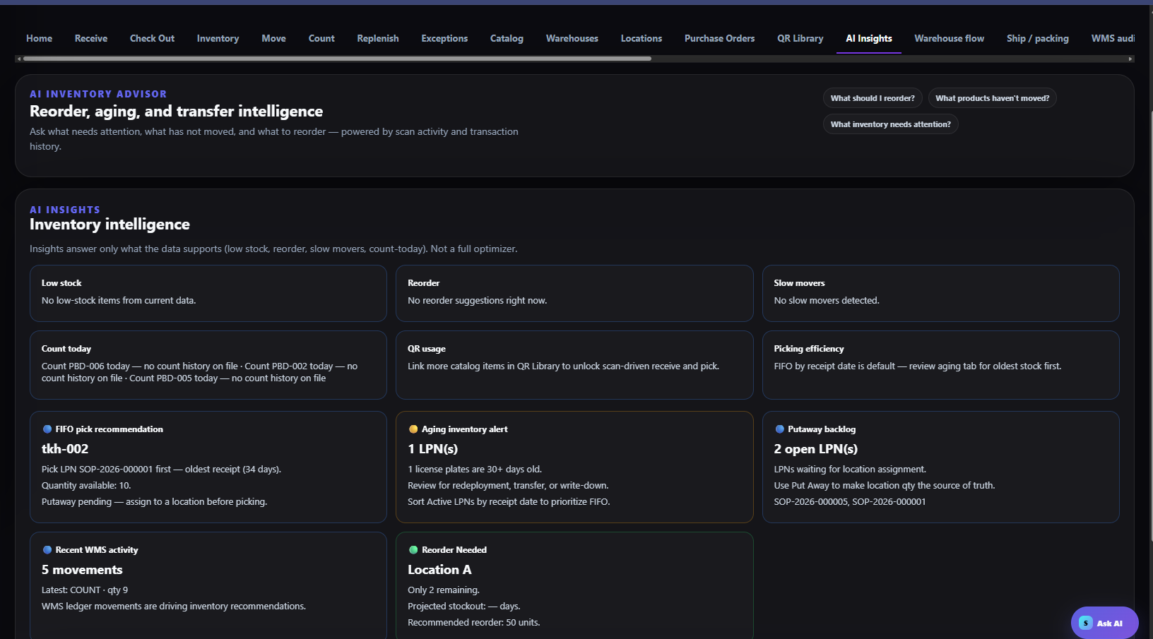
AI Insights summarizes low stock, reorder, aging, FIFO, backlog, and activity.

End-of-shift checklist
☐ Receiving variances and damaged stock are documented and isolated.
☐ All created LPNs are labeled, scan-tested, and either put away or in a controlled queue.
☐ Open moves, transfers, picks, packs, and shipments have owners and status.
☐ Quantity adjustments have reasons and approvals.
☐ Shift handoff note records unfinished work and priority exceptions.
☐ Audit trail and key counts were reviewed; exports retained when required.

REFERENCE

12. Quick troubleshooting & acceptance checks
Issue | Immediate action | Acceptance check
Unknown or duplicate SKU/LPN | Stop; quarantine transaction; notify inventory control. | One active master record and unique identifier.
Label will not scan | Reprint using approved size/contrast; inspect printer/media. | Both symbols open the correct record.
Wrong putaway location | Move through system; scan source and destination. | Physical and system locations match.
Count variance | Recount independently; review moves and open jobs. | Approved adjustment with reason/reference.
Transfer mismatch | Hold closure; compare shipped, in-transit, and received. | Both sites reconcile to documents.
Ship/track mismatch | Stop manifest; verify job, carrier label, and tracking. | Correct shipment record before dispatch.

Training sign-off
☐ Trainee can create a warehouse and location using naming standards.
☐ Trainee can import/receive stock and create, print, and scan an LPN.
☐ Trainee can put away, adjust, transfer, and reconcile inventory.
☐ Trainee can generate inventory QR labels and distinguish them from marketing QR codes.
☐ Trainee can complete pack/ship and explain the audit trail.
Supervisor: ____________________ Trainee: ____________________ Date: ____________
COMPLETION STANDARD
The SOP is complete only when the transaction, physical stock, label, location, and supporting reference all agree.

