OPERATIONS PLAYBOOK
Creating QR Codes
Including Advanced Language Options
PURPOSE Create a functional, branded, trackable QR code; explicitly configure its printed-label and after-scan languages; test the scan experience; and save it with consistent organization.

Audience QR creators, marketing, operations, inventory, and workspace administrators
Version 1.0 | Owner ScanOps Operations | Review cycle Annual

1. Scope and control standard
Use this procedure whenever a new QR code is created in ScanOps. It applies to website links and to the other available QR experiences, including digital business cards, multi-link pages, menus, inventory/assets, forms, app stores, audio, offers, email drafts, files, payments, phone calls, text messages, social profiles, Wi-Fi, and map/address destinations.
MANDATORY FEATURE Advanced Language Options must be opened and reviewed for every QR. The creator must deliberately confirm the Label / Print Language and the After Scan / Landing Language—even when the two languages are the same or the QR redirects directly.

Roles
Role | Responsibility
Creator | Enters content, sets languages, designs, tests, and creates the QR.
Reviewer / owner | Confirms destination, audience languages, branding, and final scan behavior.
Workspace admin | Maintains redirect domains, workspace branding, folders/categories, and permissions.

Before you begin
- Final destination URL or content, approved and mobile-friendly.
- QR name and optional alias, folder/category, and Marketing Hub assignment.
- Required printed-label language and visitor/landing-page language.
- Approved logo, colors, frame text, and template.
- A phone or scanner for end-to-end testing.

01 Open the QR builder
- From the left navigation, expand QR Codes.
- Select Create.
- Confirm the Build your QR page opens.
EXPECTED RESULT The Content tab is active and a QR Preview panel appears.

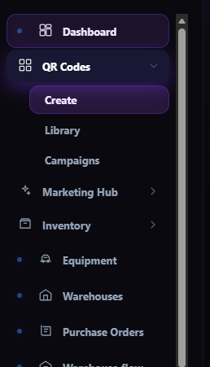
Figure 1. Navigate to QR Codes → Create.
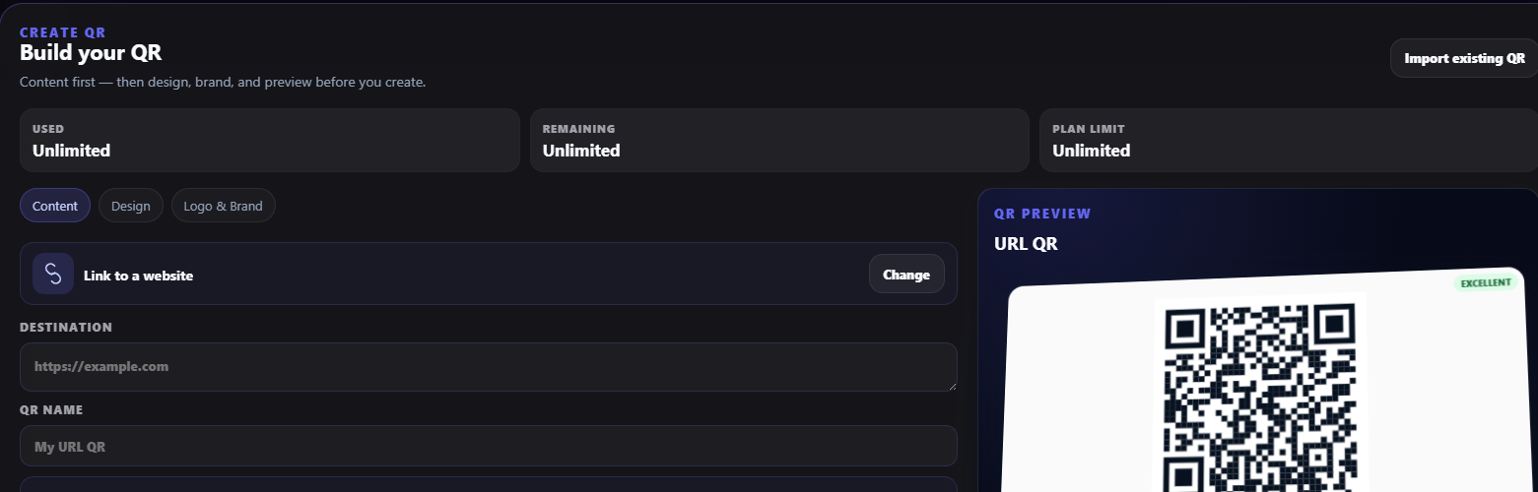
Figure 2. QR creation workspace with Content, Design, and Logo & Brand tabs.

02 Choose the QR experience
- Review the selected QR type. Link to a website is the default shown.
- Select Change to view all available experiences.
- Choose the experience that matches the scan outcome.
IMPORTANT Changing the QR type can change which content fields and language behavior are available. Choose the type before entering data.

EXPECTED RESULT The chosen QR type appears at the top of the Content tab and the relevant fields are displayed.

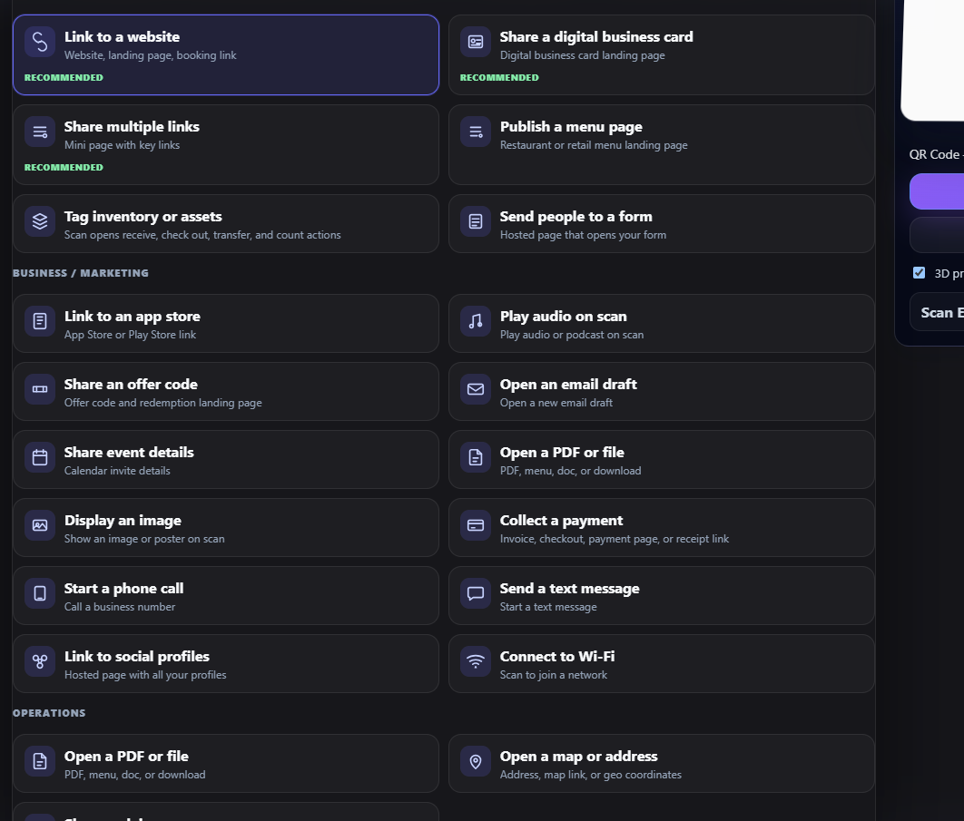
Figure 3. Available QR experiences; choose by intended scan action.

03 Enter content and naming
- Enter the Destination or required content for the chosen QR type.
- Enter a clear QR Name using an agreed convention, such as Department – Purpose – Location – Date.
- Select Redirect Mode. Use Trackable when scan analytics and later destination changes are required; use Direct only when those capabilities are not needed.
- If Trackable, confirm the Redirect Domain.
- Enable precise GPS only when there is a legitimate operational need and the user permission experience is acceptable.
- Confirm Code Format.
EXPECTED RESULT The preview updates and the redirect settings match the business use case.

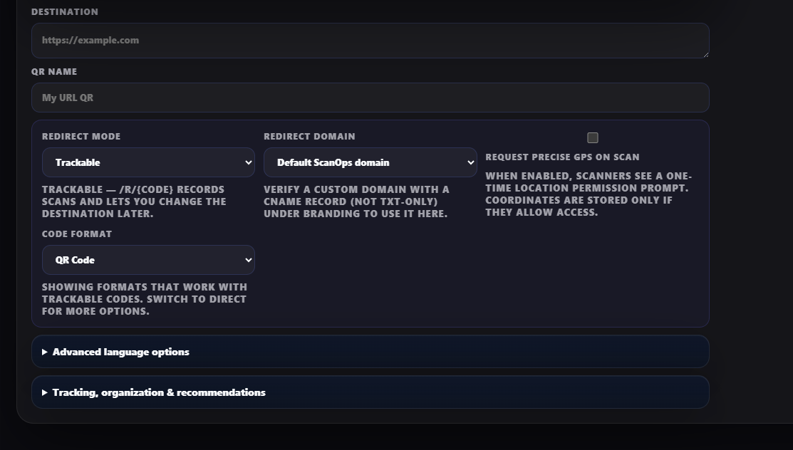
Figure 4. Destination, name, redirect, domain, GPS, and code-format controls.

04 Configure Advanced Language Options — required
- Expand Advanced Language options.
- Set Label / Print Language to the language that should appear on stickers, signs, frames, or printed instructions.
- Review the After Scan / Landing Language shown in the AI Language Coach.
- Choose one action: Use AI suggestion, Same language, or retain the selected languages after confirming the reason.
- If the QR type has no hosted landing page, still save and verify the landing language; it remains stored even when the destination redirects directly.
- Document any intentional mismatch between printed-label and landing languages in the QR naming/approval record.
IMPORTANT Do not assume the label language controls the scan experience. Printed label language and after-scan language are separate settings. A Spanish label with an English after-scan experience is valid only when intentionally approved.

EXPECTED RESULT Both language selections are deliberate, appropriate for the audience, and visible before creation.

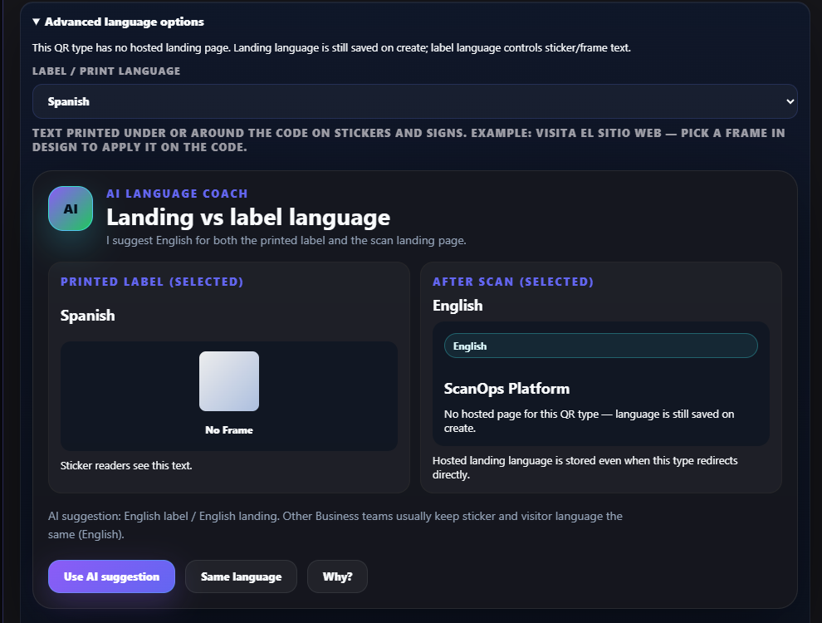
Figure 5. Advanced Language Options and AI Language Coach.

Language decision guide
Scenario | Label / Print | After Scan / Landing
Single-language audience | Use audience language | Use same language
Bilingual campaign | Use language on physical placement | Use campaign-selected visitor language or multilingual landing page
Direct URL / no hosted page | Use printed instruction language | Still select and save the intended visitor language
AI recommendation differs | Review audience and placement | Accept or override deliberately; record rationale

05 Add tracking and organization
- Expand Tracking, organization & recommendations.
- Enter an optional alias when your naming standard requires one.
- Select a folder or category.
- Choose the relevant Marketing Hub section, or leave None when the code belongs only in the All codes library.
- Review the format recommendation and listed use cases.
EXPECTED RESULT The QR can be found, governed, and reported consistently after creation.

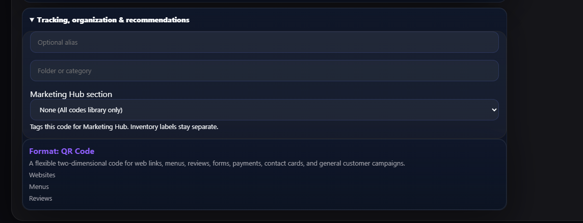
Figure 6. Alias, category, Marketing Hub, and format recommendations.

06 Apply design, frame, and template
- Open the Design tab.
- Choose a template appropriate to the use case (for example Minimal, Professional, Restaurant, Retail, Inventory Label, Warehouse, Luxury, or Modern).
- Set dot style, eye style, primary/secondary/background colors, frame, frame text, margin, and export style.
- Keep contrast in the Excellent range and avoid decorative changes that reduce scan reliability.
EXPECTED RESULT The preview matches brand standards and reports acceptable QR quality.

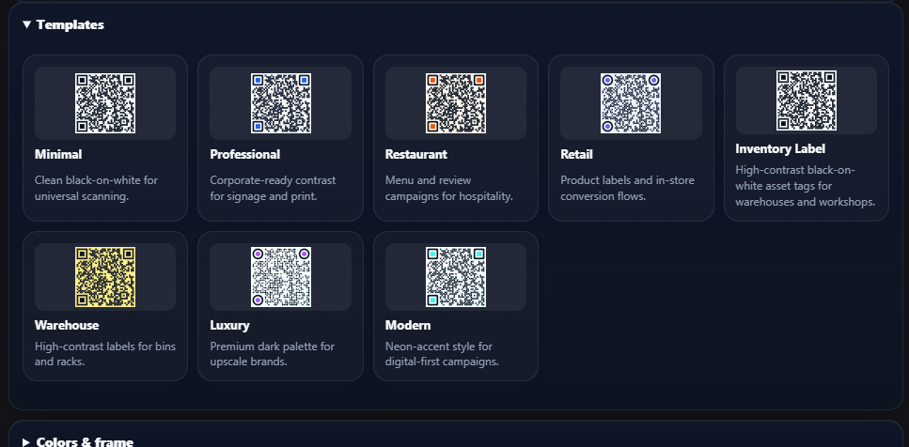
Figure 7. Available design templates.
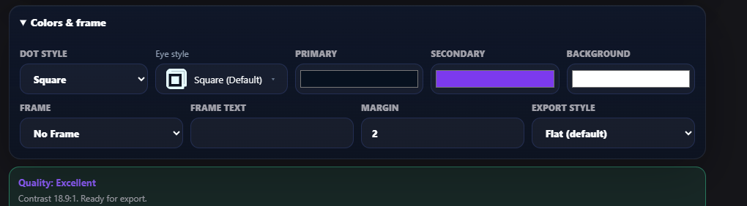
Figure 8. Colors, frame, margin, export style, and quality indicator.

07 Apply logo and brand settings
- Open Logo & Brand.
- Choose a preset logo or expand Upload & position to upload an approved custom logo.
- Select Workspace logo, Custom logo, or No logo.
- Adjust logo size and position while monitoring QR quality.
- Confirm the logo is legible at the intended printed size.
EXPECTED RESULT Only approved brand assets are used, and the code remains scannable.

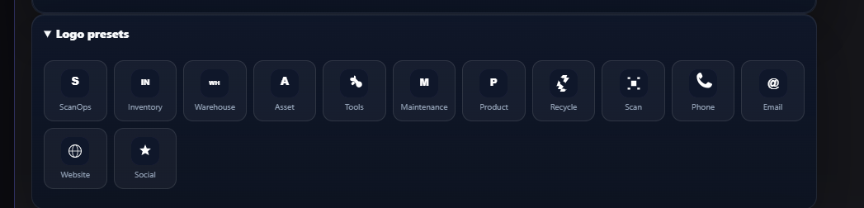
Figure 9. Logo presets.
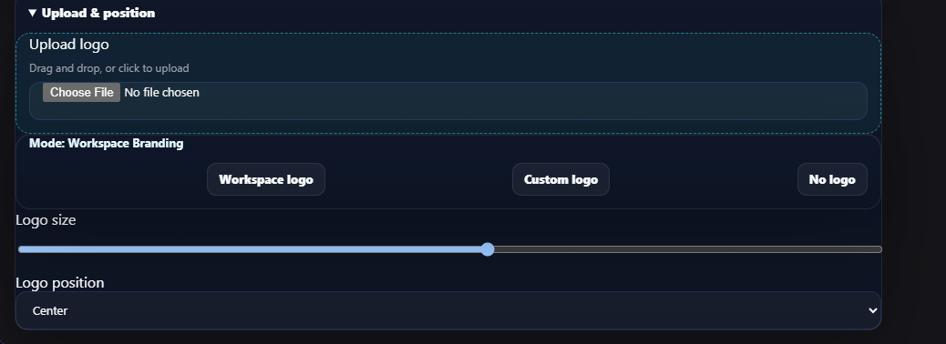
Figure 10. Logo upload, branding mode, size, and position.

08 Test the QR before creation
- In QR Preview, confirm the QR type and Trackable/Direct status.
- Select Test QR.
- Scan with at least one physical phone or scanner.
- Verify the exact destination/content, mobile behavior, permissions, printed-label language, and after-scan/landing language.
- Test at the intended print size and in representative lighting.
- Correct any issue and repeat testing.
IMPORTANT A preview image alone is not acceptance. Complete a real scan test before selecting Create QR.

EXPECTED RESULT The scan succeeds quickly and the full visitor experience—including language—is correct.

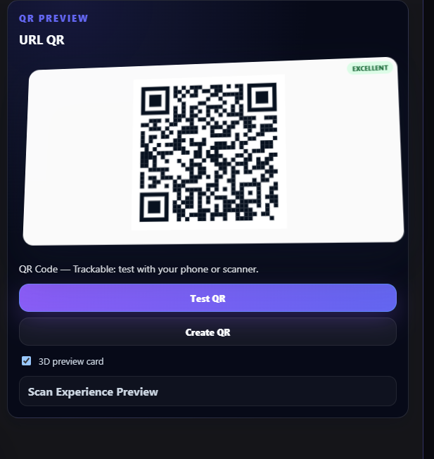
Figure 11. QR preview, Test QR, and Create QR controls.

09 Create, record, and hand off
- Select Create QR only after all acceptance checks pass.
- Open the created item in the QR library and confirm its name, alias, category, campaign assignment, redirect mode, and language settings.
- Download/export the required asset format.
- Record the owner, placement, approval date, destination, label language, after-scan language, and next review date.
- Provide the approved asset and placement instructions to the requester.
EXPECTED RESULT The QR is saved, organized, tested, and ready for controlled use.

Final acceptance checklist
- Correct QR experience selected.
- Destination/content is final, approved, and mobile-friendly.
- QR name follows the naming standard.
- Redirect mode and domain are correct.
- Advanced Language Options were opened and reviewed.
- Label / Print Language is correct.
- After Scan / Landing Language is correct.
- Any language mismatch is intentional and documented.
- Alias, folder/category, and Marketing Hub assignment are correct.
- Template, colors, frame, and logo are approved.
- Quality indicator is acceptable.
- Physical scan test passed at intended size.
- Created QR was reopened and verified in the library.

Troubleshooting and controls
Issue | Corrective action
QR does not scan | Increase contrast and margin; simplify logo/frame; test a larger size; confirm the preview quality indicator.
Wrong destination | Stop distribution. Correct a Trackable destination or create a replacement if Direct; retest and reapprove.
Wrong language after scan | Reopen Advanced Language Options, correct After Scan / Landing Language, and retest the actual scan experience.
Printed language is wrong | Correct Label / Print Language and frame text; regenerate the print asset before distribution.
Cannot find the QR | Check QR name, alias, folder/category, and Marketing Hub assignment.
Custom domain unavailable | Ask a workspace administrator to verify the custom domain under Branding; use the approved default domain until resolved.

Required creation record
Retain the following fields in the applicable request, campaign, asset register, or approval record: QR name; owner; QR type; destination; redirect mode/domain; label language; after-scan language; alias/category/campaign; template/brand selection; test device/date/result; approver; placement; and review/retirement date.
CONTROL POINT If Advanced Language Options were not reviewed, the QR is not ready for approval or distribution.

