MARKETING HUB
Using QR Codes for
Sales, Marketing & Promotions
Choose the right business section, organize codes, and measure results
PURPOSE Use the Marketing Hub when a QR code supports sales activity, ongoing marketing, or a time-bound promotion. The hub keeps these codes separate from inventory labels and the general QR Library while providing section-specific counts, scans, search, and campaign access.

Audience Sales, marketing, promotion, and campaign teams
Version 1.0 | Owner ScanOps Operations | Review cycle Annual

1. Decide which Marketing Hub section to use
KEY RULE Assign each business QR to Sales, Marketing, or Promotion according to its primary purpose.

Section | Use when | Examples | Typical next step
Sales | The QR directly supports a sales conversation or follow-up. | Quotes, demos, proposals, contact cards, booking links. | Create in Sales and associate it with the relevant opportunity or campaign.
Marketing | The QR supports ongoing brand, content, or demand-generation activity. | Web pages, content, events, reviews, lead forms, brand links. | Create in Marketing and track results by campaign.
Promotion | The QR supports a special offer or limited-time push. | Coupons, offer codes, seasonal deals, contests, limited-time promos. | Create in Promotion; record start/end dates and retire when finished.

Before creating or assigning a code
- Confirm the business owner and primary goal.
- Choose Sales, Marketing, or Promotion based on the main use—not merely the team requesting it.
- Prepare the final destination, naming convention, campaign, brand assets, languages, and success measure.
- For promotions, confirm offer terms, launch date, expiration date, and post-expiration destination.
DO NOT USE Do not place inventory or asset labels in the Marketing Hub. Those belong in Inventory.

01 Open the correct Marketing Hub section
- From the left navigation, expand Marketing Hub.
- Select Sales, Marketing, or Promotion.
- Confirm the page title and highlighted section match your intended use.
EXPECTED RESULT The appropriate business section is open and its counts, scan totals, uncategorized count, search, and code list are visible.

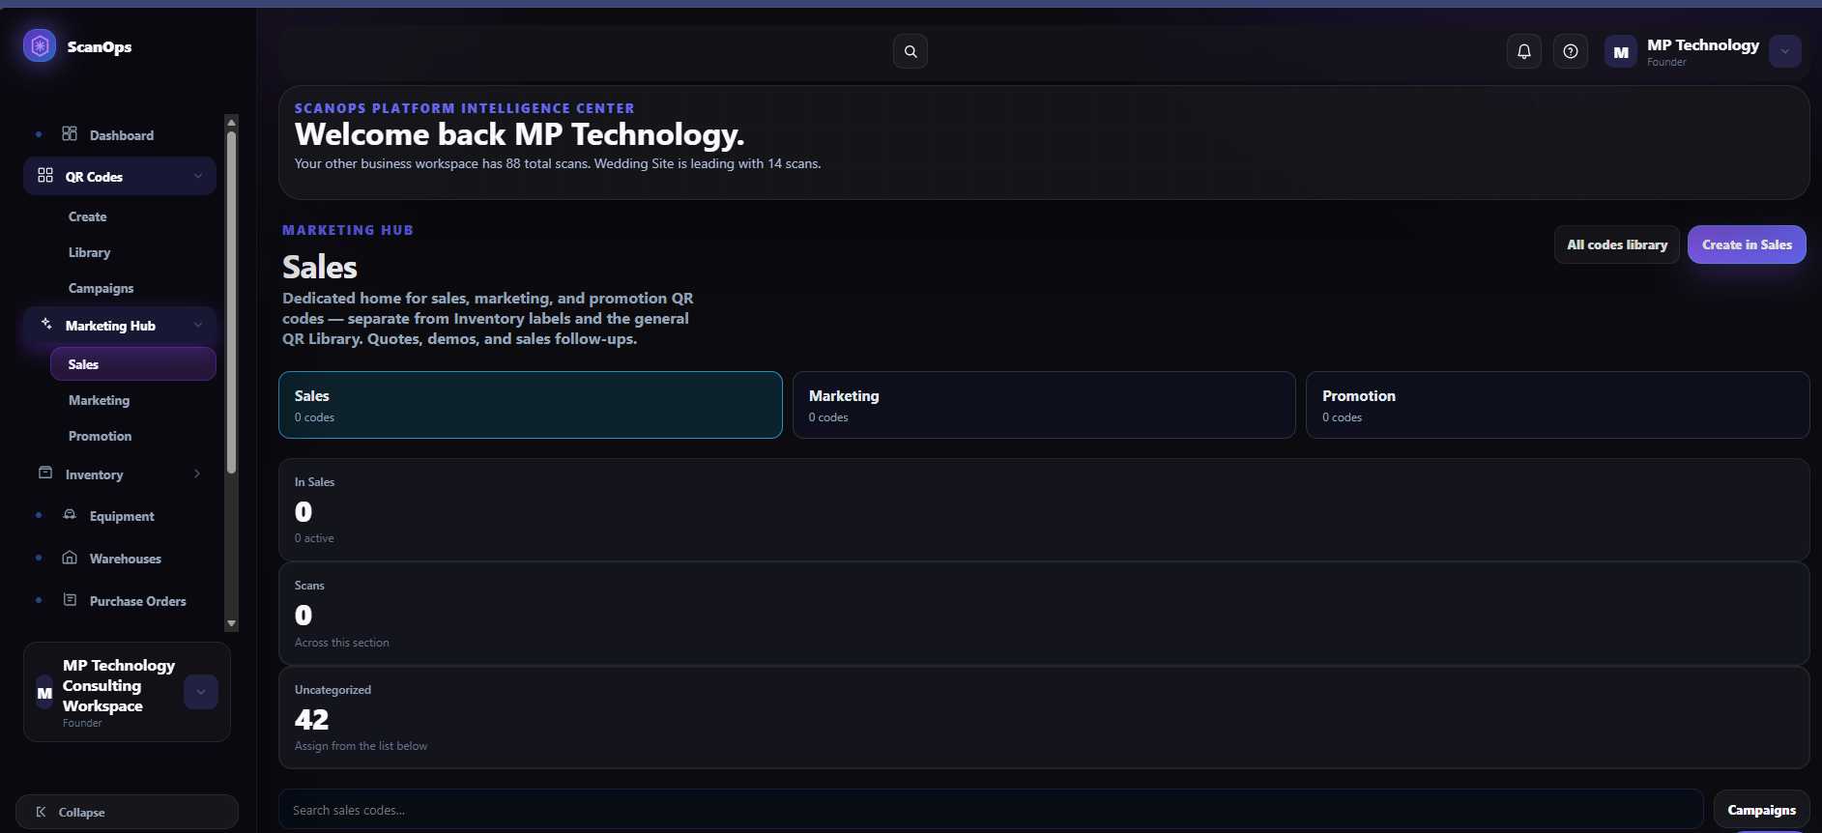
Figure 1. Sales is used for quotes, demos, and sales follow-ups.

Section examples
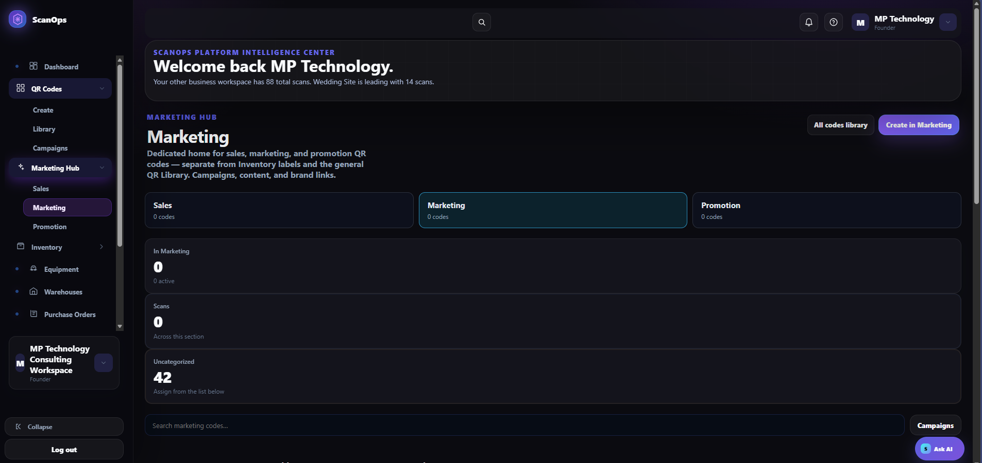
Figure 2. Marketing is used for campaigns, content, and brand links.
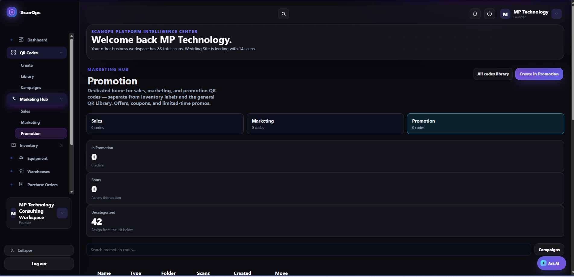
Figure 3. Promotion is used for offers, coupons, and limited-time promotions.

02 Create a QR directly in the selected section
- Select Create in Sales, Create in Marketing, or Create in Promotion.
- Complete the QR creation workflow: experience, destination, name, redirect settings, Advanced Language Options, design, branding, and test.
- Confirm the Marketing Hub section remains set to the intended section before creation.
- Create the QR only after the real-device scan test passes.
EXPECTED RESULT The new QR is created and categorized in the selected Marketing Hub section.

03 Assign an uncategorized QR
- Review the Uncategorized count.
- Use the search field to find the existing QR by name, type, folder, or destination.
- In the code list, use the Move control to assign the QR to Sales, Marketing, or Promotion.
- Reopen the destination section and confirm the section count increased and the uncategorized count decreased.
EXPECTED RESULT The existing QR appears in the correct business section and is no longer uncategorized.

QUALITY CHECK Do not categorize a code until its owner, purpose, destination, language, and active dates are known.

04 Organize with campaigns
- Select Campaigns when the QR belongs to a coordinated initiative.
- Use a clear campaign name and date range.
- Keep related Sales, Marketing, and Promotion codes aligned to the same campaign when they support one initiative.
- Record the campaign owner and performance goal.
EXPECTED RESULT QR performance can be reviewed in the context of the initiative it supports.

05 Monitor and maintain the section
- Review In Sales / In Marketing / In Promotion and the active count.
- Review Scans across the section.
- Search for the specific code and confirm its status, owner, destination, campaign, and dates.
- Use All codes library when you need the broader cross-section library.
- Test codes after destination changes and before campaign launches.
- Archive or retire expired promotions and obsolete sales/marketing assets according to approval rules.
EXPECTED RESULT The section contains current, correctly categorized codes and reliable performance data.

Measurement guide
Section | Primary measure | Review questions
Sales | Qualified scans, bookings, demos, follow-ups. | Is the QR helping move a prospect to the next step?
Marketing | Reach, unique scans, form fills, content engagement. | Is the QR reaching the intended audience and driving engagement?
Promotion | Redemptions, conversions, scan volume during offer period. | Did the offer perform during its approved dates and is it now retired?

Final verification checklist
- Primary business purpose was confirmed.
- Correct Sales, Marketing, or Promotion section was selected.
- Inventory labels were kept outside the Marketing Hub.
- Destination, language, design, and branding were approved.
- Real-device scan test passed.
- Campaign and owner were recorded when applicable.
- Uncategorized code was moved and verified, if applicable.
- Success measure and review date were defined.
- Promotion expiration and retirement plan were recorded.
CONTROL POINT Sales, Marketing, and Promotion QR codes should be created or assigned in the Marketing Hub so teams can find them, measure them, and maintain them by business purpose.

