STANDARD OPERATING PROCEDURE

Submit a Support Ticket
How to send a clear, secure, and actionable support, billing, or feature request through ScanOps.
PURPOSE
Give the support team enough verified information to understand the request, reproduce the issue, assess impact, and respond without unnecessary back-and-forth.

Use this SOP for
- System errors, unexpected behavior, or access problems
- Billing or subscription questions
- Feature requests or product feedback
- Configuration questions that cannot be resolved through approved internal guidance

Before submitting
- Confirm the correct workspace and signed-in sender shown on the form.
- Check whether the issue is already known internally or assigned to another ticket.
- Retry only safe, reversible steps; do not repeatedly submit the same transaction.
- Collect timestamps, affected records, exact error text, and reproduction steps.
EMERGENCY BOUNDARY
Do not rely on a routine ticket for an immediate life-safety, physical-security, active data-exposure, or business-critical outage response. Follow the organization’s emergency escalation process as well.

TICKET READINESS

1. Classify and prepare the request

Choose the best category
Category | Use when | Include
Support | A feature is unavailable, incorrect, slow, or producing an error. | Steps, result, time, scope, error text.
Billing | Plan, invoice, charge, seat, or subscription question. | Workspace, invoice/date, non-sensitive transaction reference.
Feature request | A new capability or workflow improvement is proposed. | Problem, users, frequency, desired outcome.
Other / closest option | No listed category fits. | Explain why and identify the affected area.

Assess impact
- Who is affected: one user, a role, a site, or the full workspace.
- What is blocked: view, scan, receive, pick, ship, report, billing, or administration.
- When it began and whether it is continuous or intermittent.
- Whether a safe workaround exists.
- Whether data, inventory, money, or customer commitments may be wrong.
ONE ISSUE PER TICKET
Create one ticket for one primary problem. Separate unrelated defects or requests so ownership, priority, and resolution remain clear.

FORM PROCEDURE

2. Complete and submit the ticket
- Open Settings → Submit a request.
- Verify the “Sending as” workspace, account, and platform identity.
- Choose the closest Category.
- Write a concise Subject using Area – Issue – Impact (example: Receiving – LPN not generated – dock blocked).
- In Message, state the expected result and actual result.
- List numbered reproduction steps and the last successful step.
- Include date/time with timezone, affected workspace/site, user role, record IDs, QR/LPN/SKU/PO references, browser/device, and exact error text when relevant.
- Describe business impact, urgency, affected users, and any safe workaround.
- Review for accuracy, duplicates, and sensitive information.
- Select Submit request once and wait for confirmation.
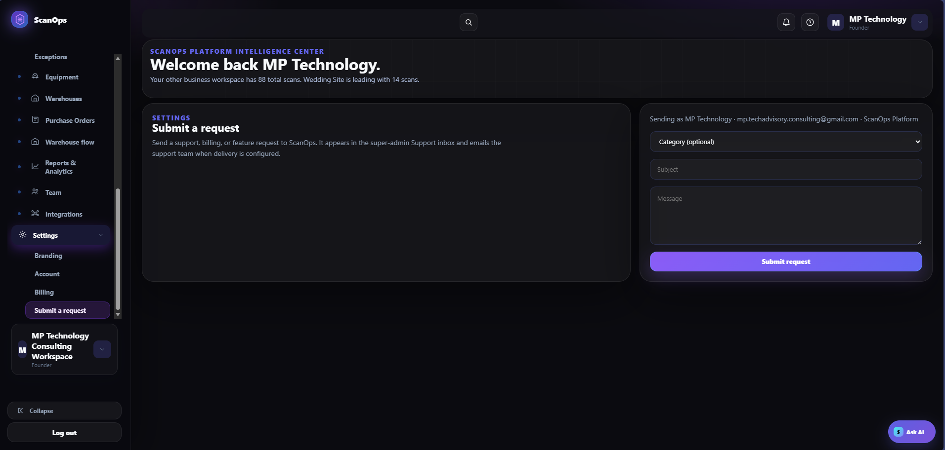
Settings → Submit a request: category, subject, message, and sender identity.
GOOD SUBJECT
Use a specific, searchable subject. Avoid “Help,” “Urgent,” “Broken,” or “Issue” without the affected area and impact.

MESSAGE STANDARD

3. Write an actionable message

Recommended structure
- Summary: one sentence describing the problem or request.
- Impact: users/sites affected, work blocked, and deadline.
- Expected: what should have happened.
- Actual: what happened, including exact error text.
- Steps: numbered actions that reproduce the issue.
- Environment: workspace, module/page, role, device/browser, and network context.
- References: non-sensitive IDs, timestamps/timezone, and related ticket number.
- Workaround: what was tried and the result.
- Contact: best responder and availability when coordination is needed.

Example
SAMPLE TICKET
Summary: Putaway does not complete after scanning a valid LPN and location. Impact: two receiving users at Main Warehouse; 14 pallets are waiting. Expected: location quantity updates and confirmation appears. Actual: button remains active with no confirmation. Steps: 1) Open Put Away; 2) scan LPN SOP-…; 3) scan location A-01-01; 4) select Confirm. Time: 9:42 AM ET. Workaround: none; stock isolated in receiving.

Evidence
- Include screenshots only when they show the relevant page, error, timestamp, or status.
- Crop unrelated browser tabs, desktop content, personal information, and confidential records.
- Never alter evidence in a way that changes its meaning.

SECURITY AND PRIVACY

4. Protect sensitive information

Never include
- Passwords, temporary passwords, Floor PINs, authentication codes, API keys, tokens, private keys, or recovery codes.
- Full payment-card, bank-account, government-ID, health, or other regulated personal data.
- Unredacted customer lists, confidential contracts, or unrelated employee information.
- DNS credentials or carrier/integration secrets.

Use safer references
- Use the last four digits or approved transaction/reference ID instead of full financial details.
- Use system record IDs rather than copying full personal records.
- Describe the secret type and where it is configured—never paste the secret value.
- Redact screenshots while preserving the error, page, and relevant identifier.
SUSPECTED EXPOSURE
If a secret or sensitive record was accidentally included, immediately follow the security incident process, rotate the exposed credential where applicable, and notify the authorized security owner. Do not merely submit a second ticket asking to ignore it.

TICKET LIFECYCLE

5. Confirm, track, and close

After submission
- Capture the ticket/reference number and submission time.
- Record the ticket in the team’s issue log with owner, category, impact, and status.
- Do not submit duplicates. Add new evidence to the existing ticket or reference it in follow-up.
- Respond promptly to support questions and retest only the requested or approved steps.
- If business impact changes, update the ticket with new facts rather than changing urgency without evidence.

Escalation
- Escalate through the organization’s approved path when impact becomes critical, the safe workaround fails, or a committed deadline is at risk.
- Reference the existing ticket number, current impact, actions taken, and required decision.
- Do not bypass access, security, or change controls to create a workaround.

Closure
- Verify the resolution in the affected workspace and workflow.
- Confirm data, balances, QR destinations, permissions, or billing results are correct.
- Document the test performed and outcome.
- Close the internal issue record and share any approved workaround or lesson learned.

REFERENCE

6. Final checklist & troubleshooting

Submission checklist
☐ Correct workspace and sender verified
☐ Best category selected
☐ Specific subject written
☐ Expected and actual results included
☐ Reproduction steps included
☐ Impact, time, timezone, and scope included
☐ Relevant non-sensitive IDs included
☐ Safe troubleshooting attempts documented
☐ Secrets and regulated data excluded
☐ Duplicate ticket check completed
☐ Submission confirmation/reference recorded

Common issues
- Submit button does not respond: confirm required Subject and Message fields, preserve the text, refresh safely, and retry once.
- Wrong category selected: reference the ticket and ask support to reclassify; do not duplicate it.
- No confirmation received: verify the form status and sender email, then check the internal issue log before resubmitting.
- Cannot reproduce: add timestamps, role, device/browser, record identifiers, and whether the issue is intermittent.
- Support asks for a password or secret: do not send it; use the approved secure process and verify the requester.
COMPLETION STANDARD
A ticket is properly submitted when it is accurate, reproducible, securely written, assigned a reference, tracked internally, and verified through resolution or approved closure.

