STANDARD OPERATING PROCEDURE

View & Pay an Invoice
How authorized users review billing history, validate invoice details, submit payment securely, and retain payment records.
PURPOSE
Ensure every invoice is reviewed, approved, paid through the authorized billing workflow, and documented without exposing payment credentials.

Applies to
- Workspace Owners or authorized billing users
- Accounts payable and finance reviewers
- Managers responsible for plan or subscription approval

Required controls
- Use only the Billing page reached from the authenticated workspace.
- Confirm workspace, plan, invoice number, status, amount, currency, and due date before payment.
- Follow the organization’s approval and purchasing rules.
- Never share full payment details, passwords, or authentication codes.
- Retain the invoice and payment confirmation according to records policy.
ACCOUNT NOTE
If the account banner says “no billing required,” do not assume every historical row requires payment. Review the invoice status and details and escalate any inconsistency before paying.

INVOICE REVIEW

1. Open and review billing history
- Sign in to the correct workspace using an Owner or authorized billing account.
- Open Settings → Billing.
- Review the account/plan banner and confirm the billing expectation.
- In Invoices & payments, locate the invoice by invoice number.
- Review plan, status, amount and currency, due date, and available actions.
- Select the invoice row or View to open invoice details.
- Compare the invoice to the approved plan, order, contract, renewal, or internal authorization.
- Check the legal/business name, billing period, line items, taxes/fees, credits, total, and payment status when shown.
- Do not pay if any field is unexpected or unsupported.
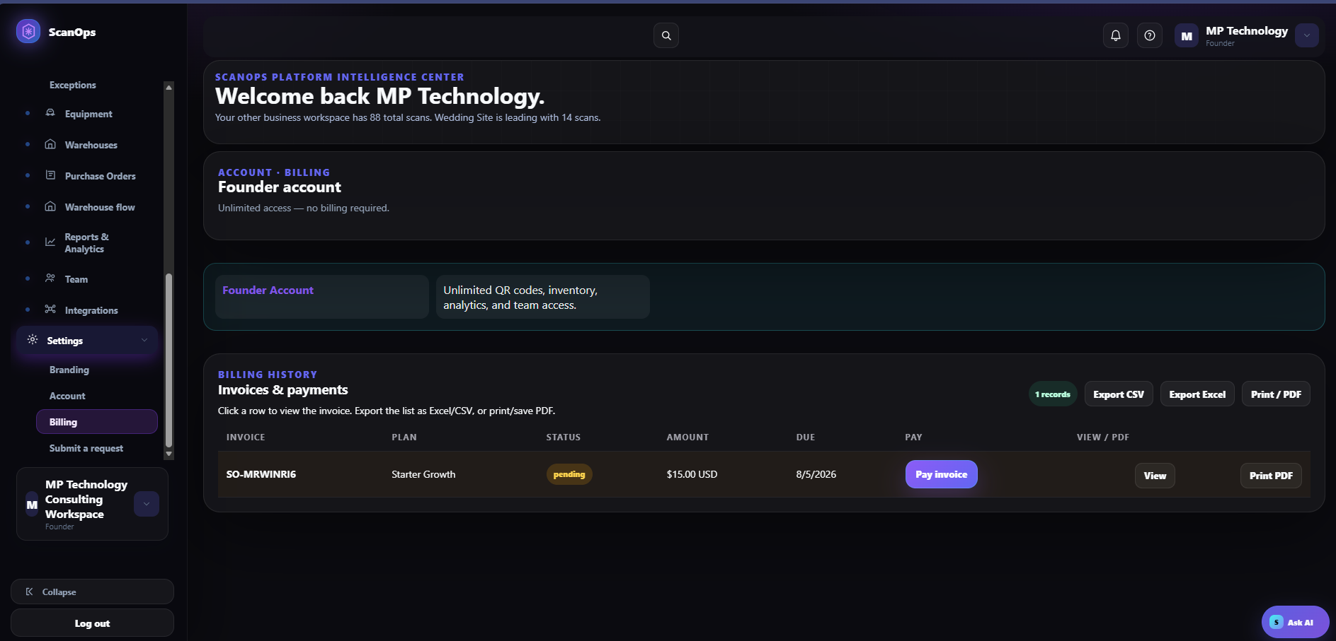
Settings → Billing: account plan, invoice status, amount, due date, payment, view, and PDF options.
STATUS GUIDE
Pending/open generally requires review and payment. Paid requires confirmation and filing. Failed, overdue, void, refunded, or disputed requires the matching finance/support procedure before further action.

DOCUMENTATION

2. Download, print, or export records

Individual invoice
- Select View to inspect the invoice before saving.
- Select Print PDF for a printable copy.
- Use the system print dialog to print or save as PDF according to company policy.
- Name the file using a controlled convention such as Vendor_InvoiceNumber_InvoiceDate_Status.pdf.
- Store it in the approved finance location with appropriate access controls.

Billing-history list
- Use Export CSV or Export Excel when a reconciliation list is required.
- Verify the export includes the expected invoice count and reporting period.
- Do not treat the list export as a substitute for the detailed invoice or payment receipt.
- Protect exports because they may contain financial and account information.

Record check
- Invoice number and date match the billing page.
- Amount, currency, due date, plan, and status are readable.
- The PDF is complete and not blank or clipped.
- The stored filename and folder follow records policy.
AVOID DUPLICATES
Before saving another copy, check whether the invoice already exists in the approved finance repository. Preserve the authoritative version and status history.

PAYMENT

3. Approve and pay a pending invoice

Before selecting Pay invoice
- Confirm the invoice is legitimate, accurate, due, and not already paid.
- Confirm approval authority, cost center, and available payment method.
- Verify the workspace and invoice number again.
- Resolve unexpected plan changes, duplicate charges, tax issues, or amount differences first.
- From the verified invoice row, select Pay invoice.
- Confirm the payment page or secure payment window belongs to the authorized billing workflow.
- Review invoice number, merchant/payee, amount, currency, and total immediately before entry.
- Enter payment details directly into the secure payment form. Do not paste or store them in notes, tickets, or screenshots.
- Complete any required authentication using the authorized account owner/device.
- Review the final confirmation screen, then submit once.
- Wait for confirmation; do not click repeatedly if processing is slow.
- Record the confirmation or receipt number and payment time.
ANTI-FRAUD STOP
Stop if the payee, domain, amount, currency, bank instructions, or payment method changed unexpectedly; if a link came from an unsolicited message; or if someone requests payment credentials outside the secure billing form.

POST-PAYMENT

4. Confirm payment and reconcile
- Return to Settings → Billing through the authenticated workspace.
- Refresh or reopen Billing and find the invoice.
- Confirm the status changed to Paid or the expected processing status.
- Open View and verify the paid amount, payment date, and balance.
- Download or print the updated invoice and receipt when available.
- Match the confirmation to the accounting or card/bank record.
- Update the internal accounts-payable record and attach the invoice/receipt.
- Notify the owner only after system and financial records agree.

If status remains pending
- Do not immediately submit a second payment.
- Check for an on-screen confirmation, receipt, or pending authorization.
- Review the payment account for a pending or completed transaction.
- Allow the documented processing period, then refresh.
- Submit a support/billing request with invoice number, time, amount, and non-sensitive transaction reference.
DUPLICATE-PAYMENT PREVENTION
When the result is uncertain, investigate the existing attempt first. Never retry solely because the Billing row did not update immediately.

CONTROLS

5. Exceptions, disputes & payment security

Failed or declined payment
- Record the displayed error without capturing full payment details.
- Confirm invoice status and whether any authorization was created.
- Verify the approved method is valid and available.
- Retry only after the cause is understood and approval remains valid.
- Use Submit a request for unresolved billing issues.

Incorrect or disputed invoice
- Do not pay an invoice with an unexplained amount, plan, tax, date, currency, or duplicate line.
- Save the invoice and supporting approval/contract.
- Submit a billing request referencing the invoice number and discrepancy.
- Track the dispute and preserve the original invoice and later adjustment/credit.

Sensitive data rules
- Never include full card or bank details in tickets, email, chat, exports, or screenshots.
- Never share one-time codes, passwords, recovery codes, or session links.
- Use approved last-four digits or non-sensitive transaction references.
- Redact unrelated financial and personal information before sharing evidence.
SUSPECTED COMPROMISE
Stop payment activity, notify the authorized finance/security owner, secure or replace the payment method as required, and preserve evidence. Do not continue testing with the exposed credential.

REFERENCE

6. Final checklist & troubleshooting

Payment checklist
☐ Correct workspace and billing account verified
☐ Invoice number, plan, status, amount, currency, and due date checked
☐ Detailed invoice reviewed
☐ Internal approval documented
☐ Invoice confirmed not already paid
☐ Secure payment workflow verified
☐ Payment submitted once
☐ Confirmation or receipt recorded
☐ Billing status rechecked
☐ Accounting record reconciled
☐ Invoice and receipt stored securely

Common issues
- No Pay invoice button: the invoice may be paid, void, nonpayable, restricted by role, or not require billing; open View and verify status.
- Cannot open invoice: confirm role/workspace, refresh safely, and submit a billing request with the invoice number.
- Print PDF is blank or incomplete: use View first, retry print/save, and verify the final file before filing.
- Amount differs from approval: stop and request correction—do not pay and reconcile later.
- Payment submitted but no receipt: investigate the existing attempt and account authorization before retrying.
- Export does not match the invoice: use the detailed invoice as the primary document and report the mismatch.
COMPLETION STANDARD
The invoice is complete only when it is validated, authorized, paid through the secure workflow when required, reflected in Billing, reconciled to the financial record, and securely filed.

