QR LIBRARY
Viewing & Managing
Created QR Codes
Where users can find every QR created in the workspace
PURPOSE Use the QR Library as the central location to view created campaign and web QR codes, check status and scan performance, find specific codes, and access sharing, export, and management actions.

Audience QR creators, marketing, operations, and workspace administrators
Version 1.0 | Owner ScanOps Operations | Review cycle Annual

1. Where created QR codes are located
KEY MESSAGE All created campaign and web QR codes are viewed under QR Codes → Library.

The QR Library displays website, menu, review, PDF, event, contact, and other campaign/web codes. Inventory labels are separated from this default view and are available under Inventory → QR Library or by selecting Show inventory labels when that option is available.

01 Open the QR Library
- From the left navigation, expand QR Codes.
- Select Library.
- Confirm the page title reads QR Library.
EXPECTED RESULT The dashboard summary and list of created QR codes are visible.

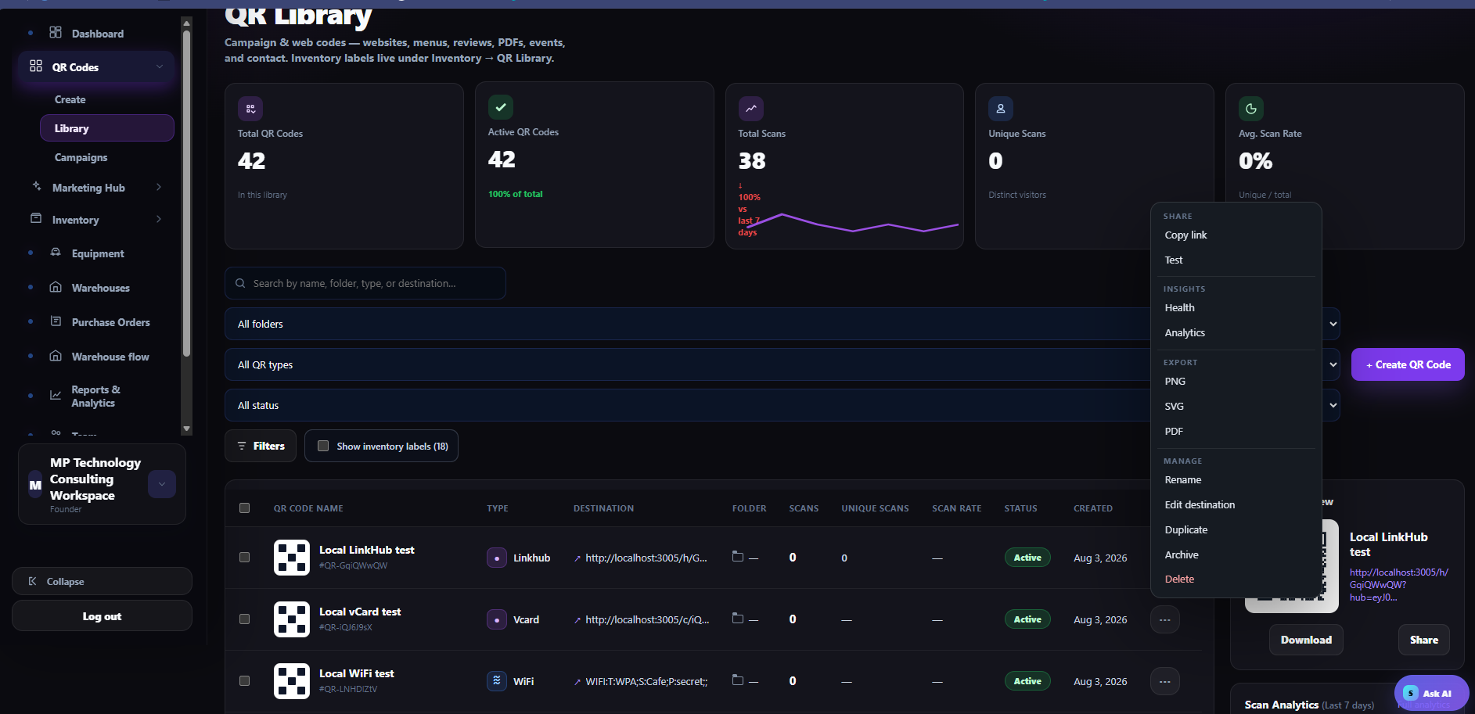
Figure 1. QR Codes → Library is the central view for created QR codes.

02 Read the library summary
- Review Total QR Codes to see how many codes are in the current library.
- Review Active QR Codes to see how many codes are currently active.
- Review Total Scans, Unique Scans, and Avg. Scan Rate for a high-level performance snapshot.
EXPECTED RESULT The user understands the size, active status, and overall scan activity of the library.

QR list columns
Column | What it shows
QR Code Name | Name and identifying code for the created QR.
Type | QR experience, such as Linkhub, VCard, or WiFi.
Destination | The URL, action, or encoded destination.
Folder | Assigned folder or category.
Scans / Unique Scans | Total activity and distinct visitors.
Scan Rate | Current scan-rate metric, when available.
Status | Whether the QR is Active or archived/inactive.
Created | The creation date.

03 Find a specific created QR
- Use Search to find a QR by name, folder, type, or destination.
- Use the folder, QR type, and status dropdowns to narrow the list.
- Select Filters for additional criteria.
- Select Show inventory labels when you need inventory-label QRs in this view.
EXPECTED RESULT Only the relevant created QR codes remain in the results.

04 Open and review a QR
- Select a QR row to view its details and preview.
- Confirm the QR name, type, destination, status, created date, and scan data.
- Use the preview panel to verify that you selected the correct code.
- If needed, select Download or Share from the preview panel.
EXPECTED RESULT The correct created QR is identified and its details are verified.

05 Use the three-dot action menu
- Select the three-dot menu on the required QR row.
- Under Share, use Copy link or Test.
- Under Insights, use Health or Analytics.
- Under Export, download PNG, SVG, or PDF.
- Under Manage, use Rename, Edit destination, Duplicate, Archive, or Delete.
EXPECTED RESULT The chosen action is completed for the correct QR.

CAUTION Archive or Delete only after confirming the QR name, destination, owner, and business impact. Deleting may make a distributed QR unusable.

Action reference
Group | Action | Use
Share | Copy link / Test | Share the destination or verify the scan experience.
Insights | Health / Analytics | Review code condition and scan performance.
Export | PNG / SVG / PDF | Download the QR in the required format.
Manage | Rename / Edit | Correct metadata or a trackable destination.
Manage | Duplicate | Create a copy for reuse or variation.
Manage | Archive | Remove from active use while retaining the record.
Manage | Delete | Permanently remove only with authorization.

Final verification checklist
- Opened QR Codes → Library.
- Confirmed the correct QR using name, type, destination, and preview.
- Applied search and filters as needed.
- Reviewed status and scan data.
- Selected the correct export or management action.
- Tested the QR after any destination or configuration change.
- Obtained authorization before archive or delete.

Troubleshooting
QR is not listed: Clear filters; search by name or destination; check folder and status; enable Show inventory labels when appropriate.
Wrong code selected: Compare the QR name, identifier, type, destination, created date, and preview before acting.
No scan data: Confirm the QR is active and distributed, then use Test and Health to validate the scan path.
Cannot edit destination: The QR may be direct or your role may lack permission. Contact a workspace administrator.
Inventory label missing: Use Show inventory labels or navigate to Inventory → QR Library.
CONTROL POINT The QR Library is the source of truth for viewing and managing created campaign and web QR codes.

